МИНОБРНАУКИ РОССИИ

Федеральное государственное бюджетное

образовательное учреждение высшего образования

«ЧЕРЕПОВЕЦКИЙ ГОСУДАРСТВЕННЫЙ УНИВЕРСИТЕТ»

Институт Информационных Технологий

Кафедра МПО ЭВМ

Дисциплина «Теория автоматов и формальных языков»

Лабораторная работа №3-4

«Распознавание заданных слов языка программирования»

Выполнил:

студент группы 1ПИб-02-3оп-22

Маркелов Сергей Александрович

Проверил:

доцент, к.т.н.

Ганичева Оксана Георгиевна

Череповец, 2024 год

Задания

1. Построить синтаксические диаграммы (конечный автомат) для распознавания заданных слов языка программирования – идентификаторов и целых констант.

Применительно к курсовой работе в качестве заданных слов берутся все слова из программного кода, который был написан в лабораторной работе №1, в соответствие с вариантом задания - это доработка кода.

1. Написать программу для распознавания слов языка С++ по своему варианту задания (идентификаторы и целые константы). Правильные слова должны заноситься в таблицу. На словах с ошибкой - выдаваться сообщение об ошибке.
2. Составить блок-схему алгоритма решения задачи.
3. Оформить отчет (задание, блок-схема алгоритма, код программы с комментариями, результаты тестирования программы (не менее 10 тестовых заданий), скриншоты результатов)

|  |  |
| --- | --- |
| Вариант | Задание |
| 14 | Оператор switch и if языка С++ |

1. Граф автомата

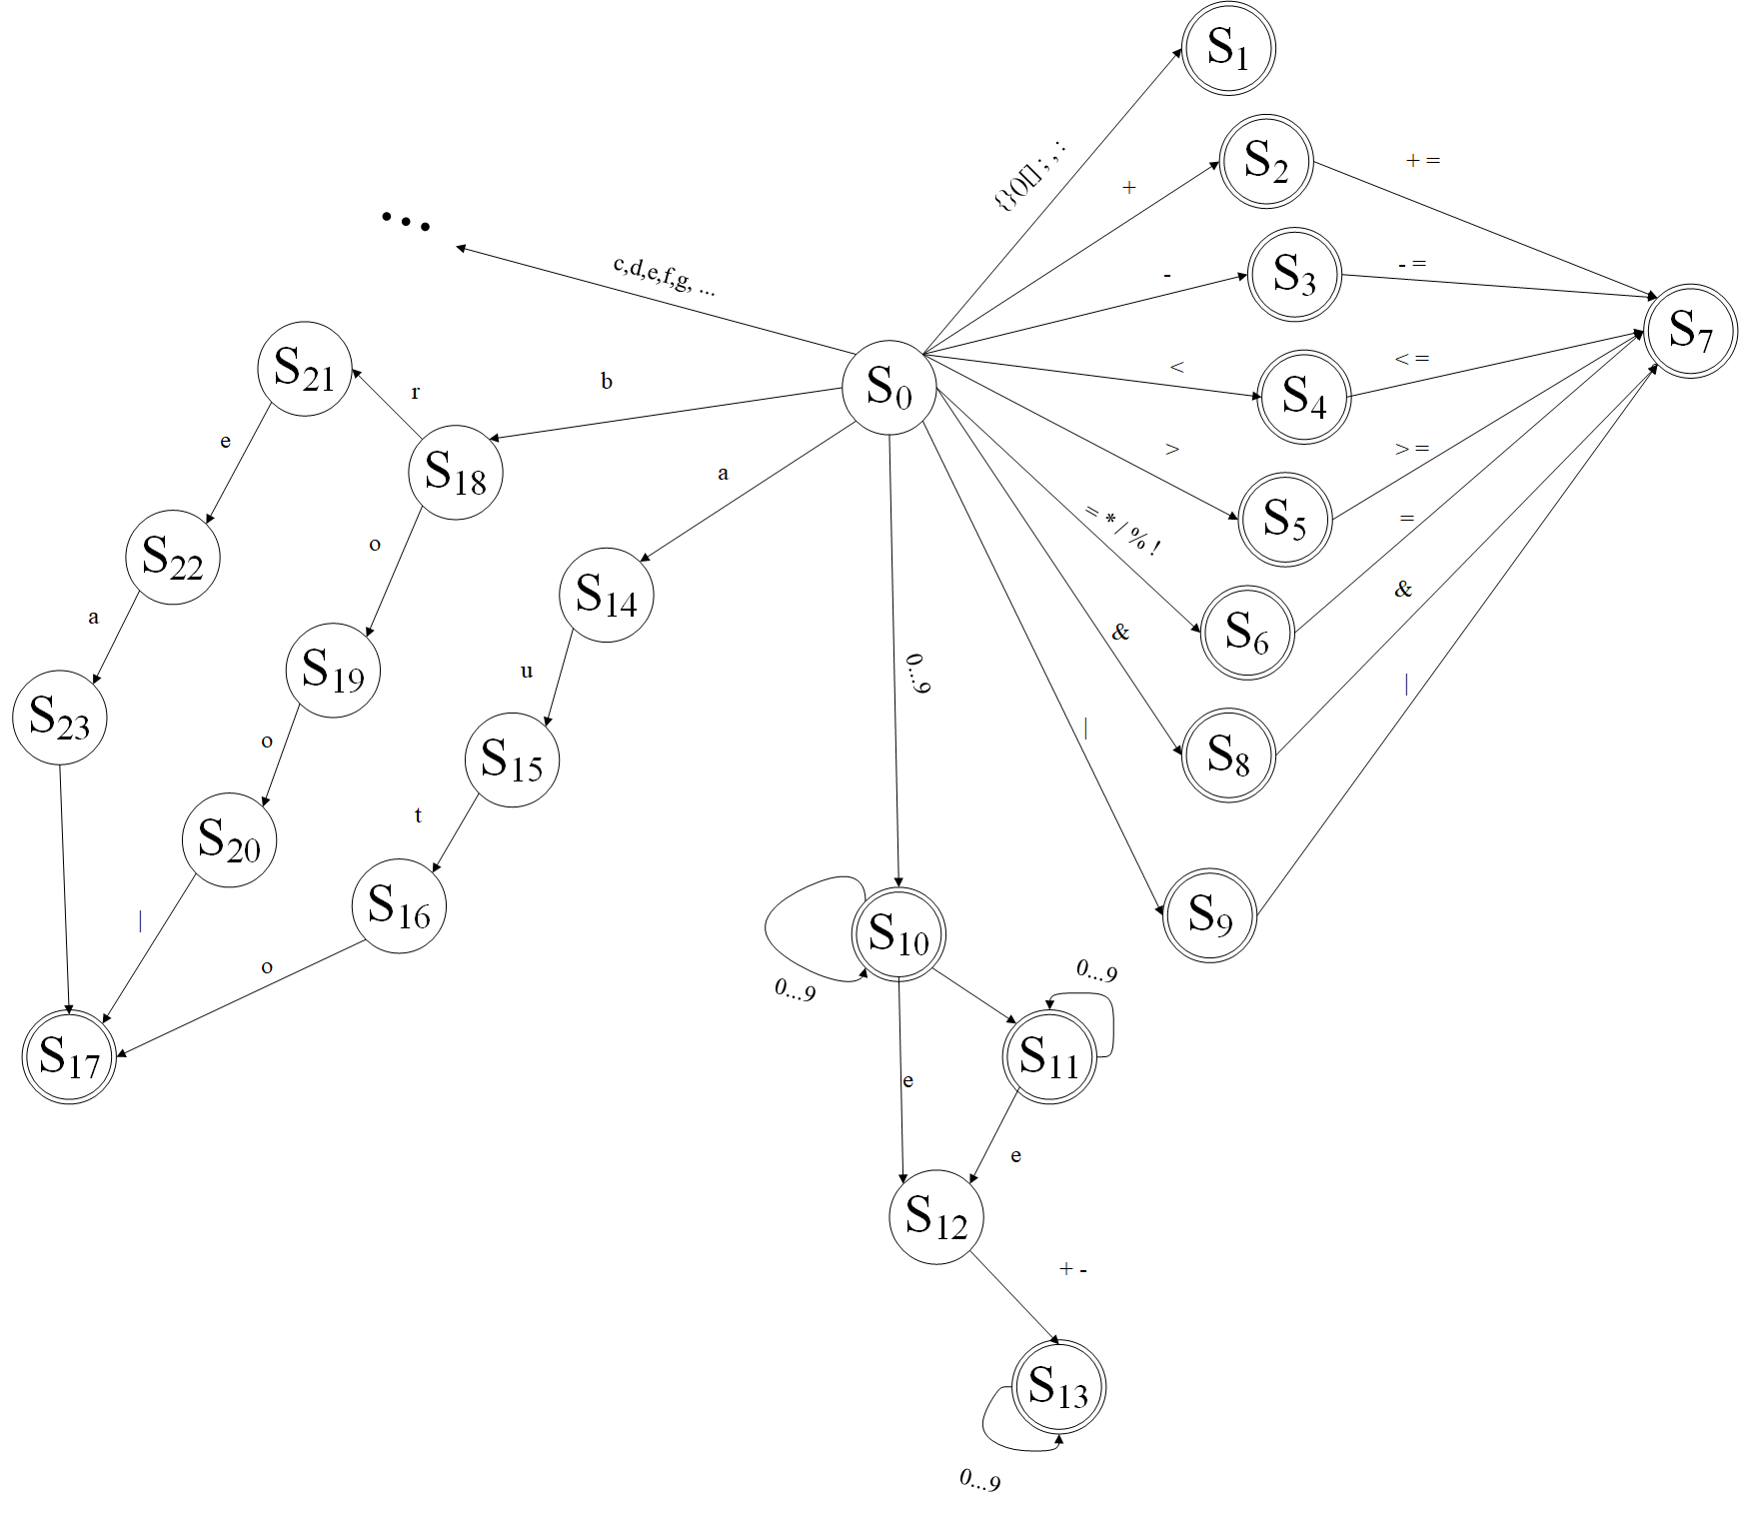

1. Блок-схема

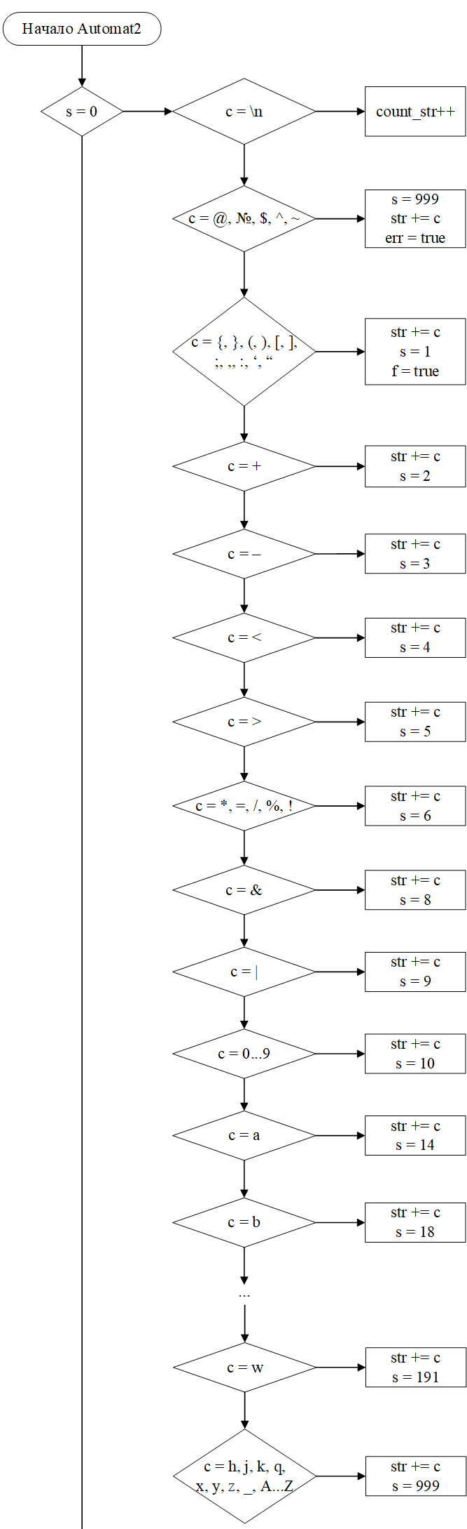

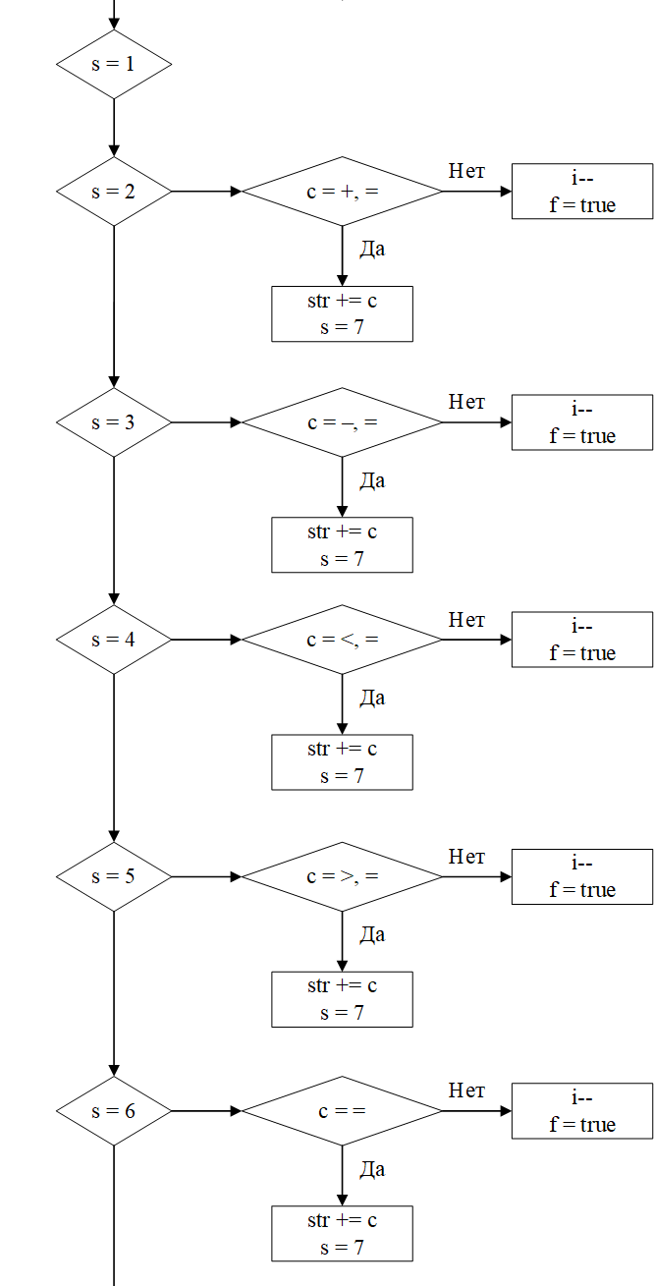

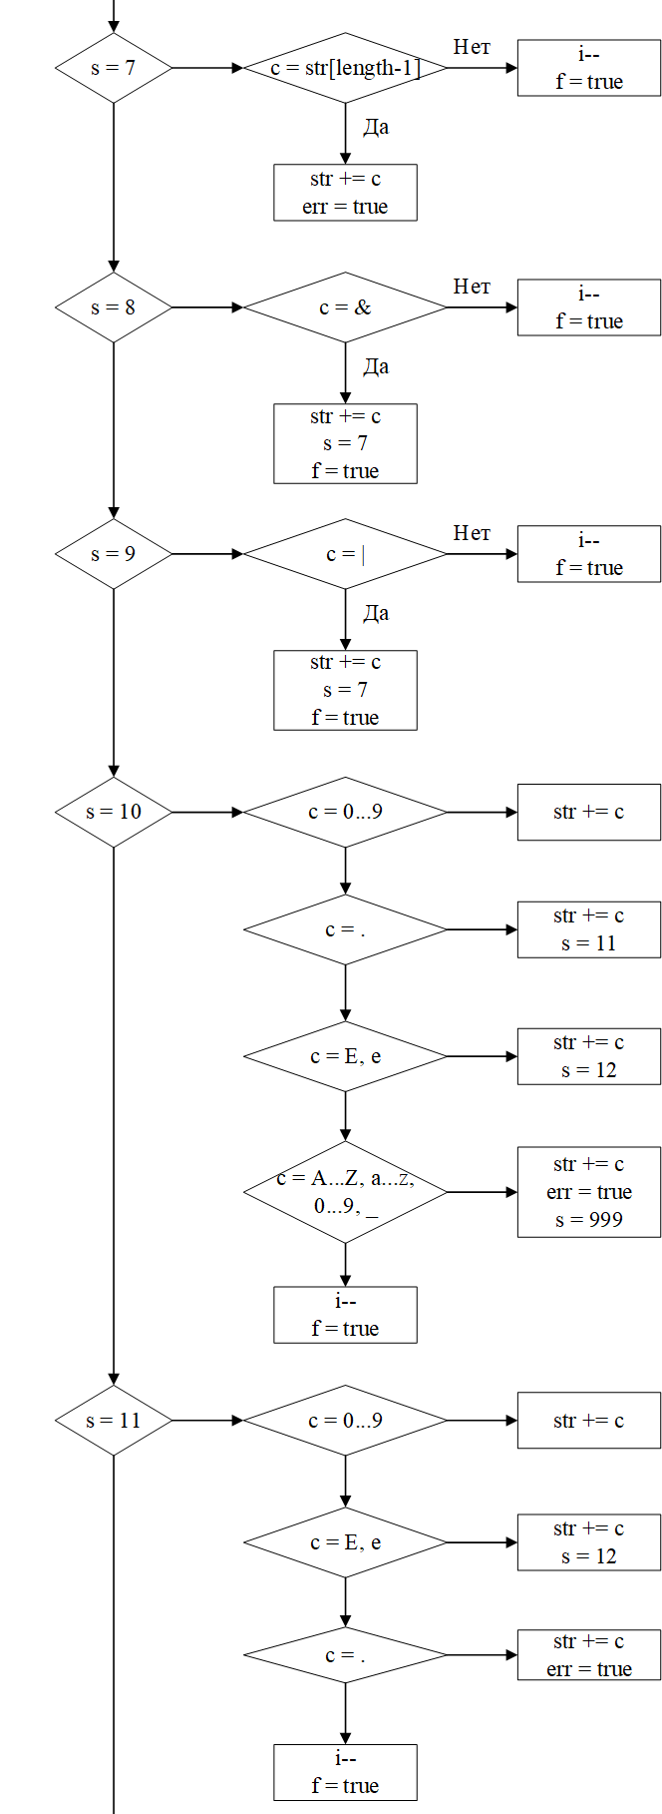

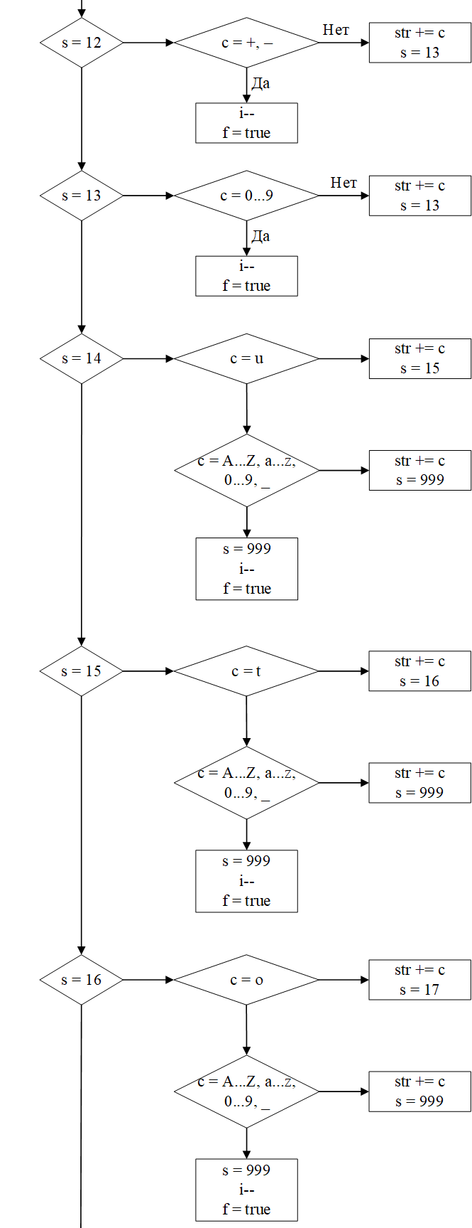

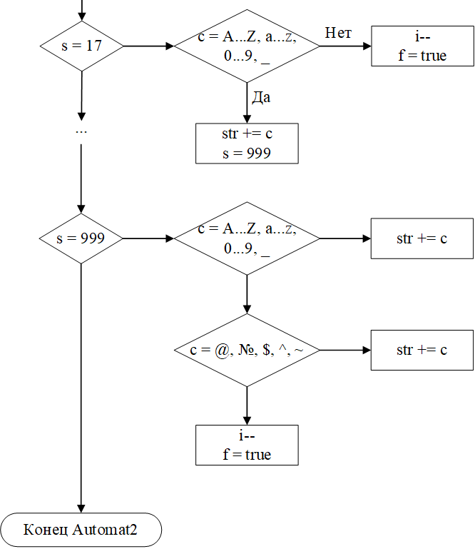

3.Тестирование

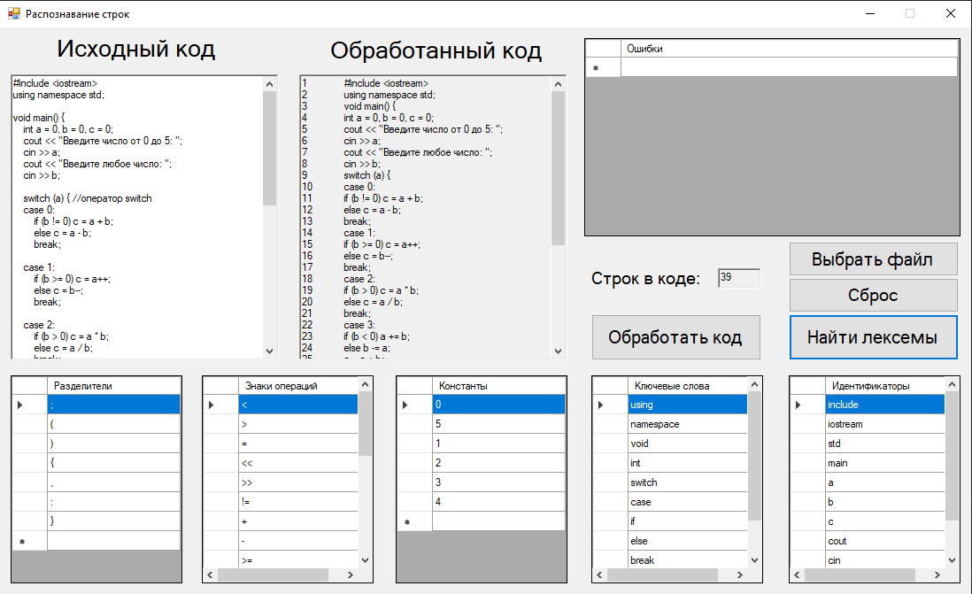

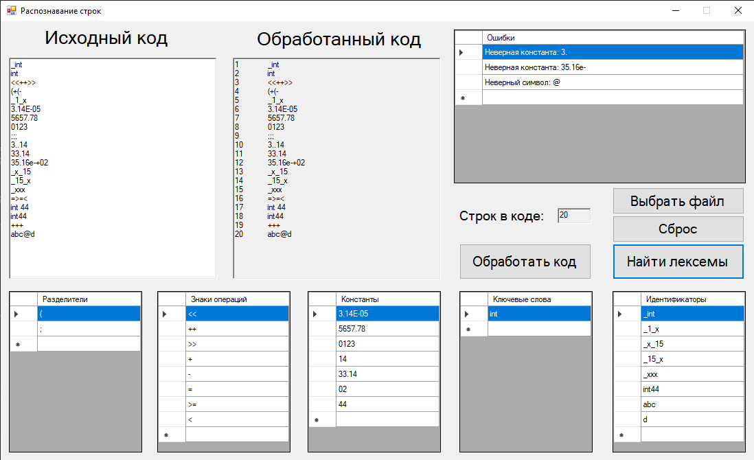

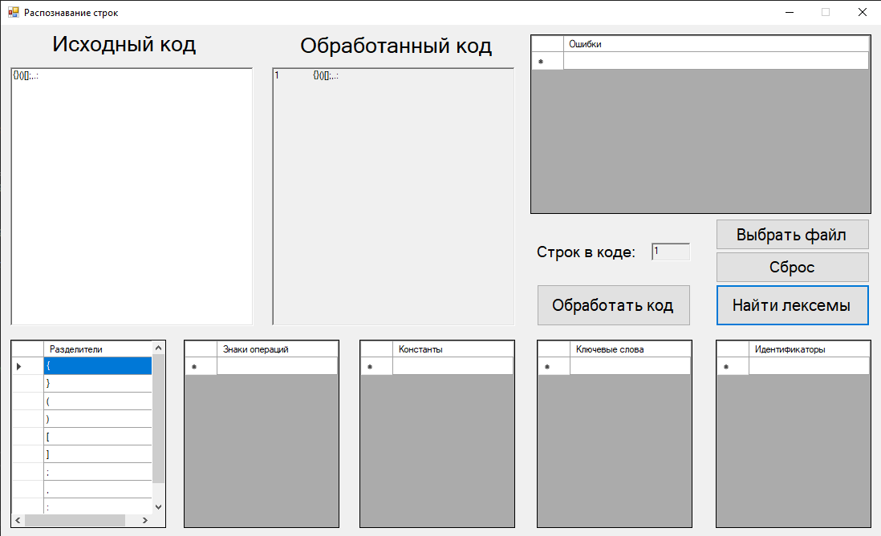

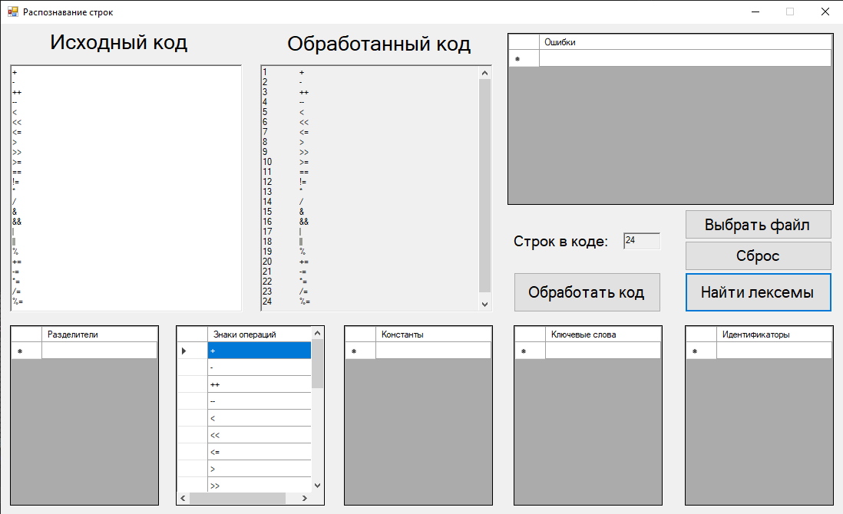

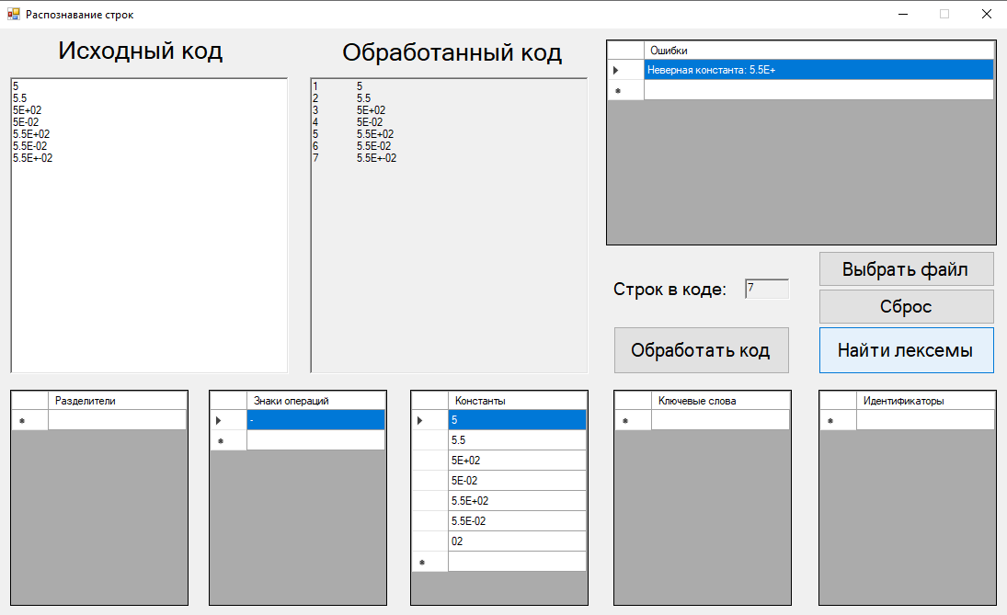

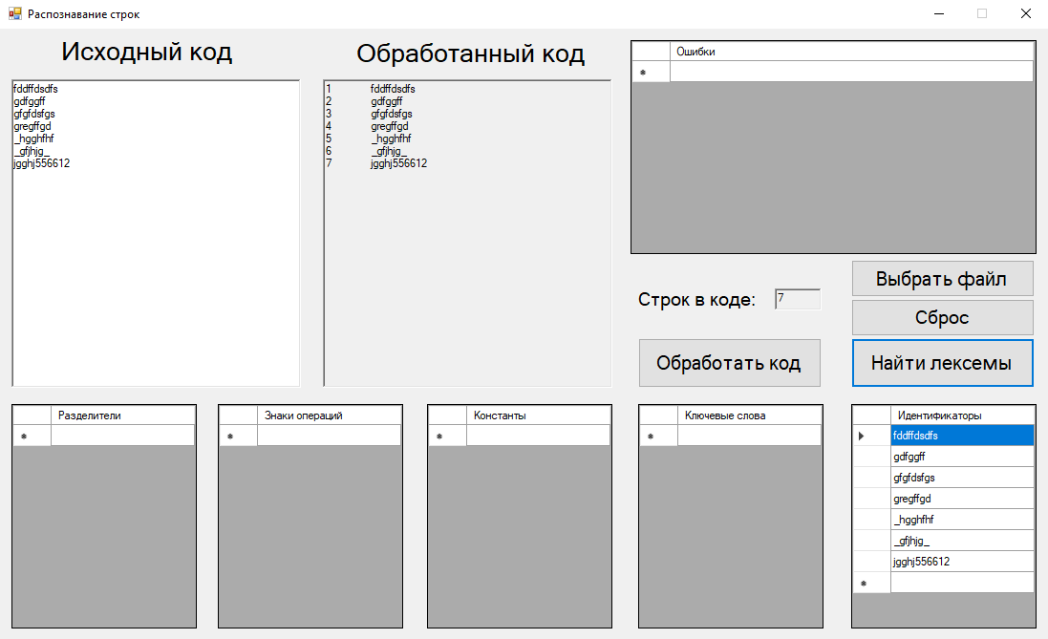

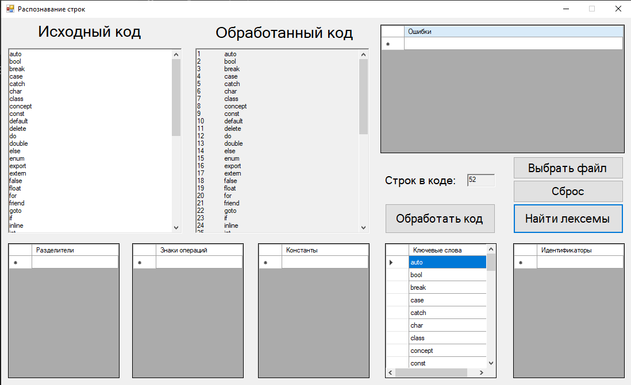

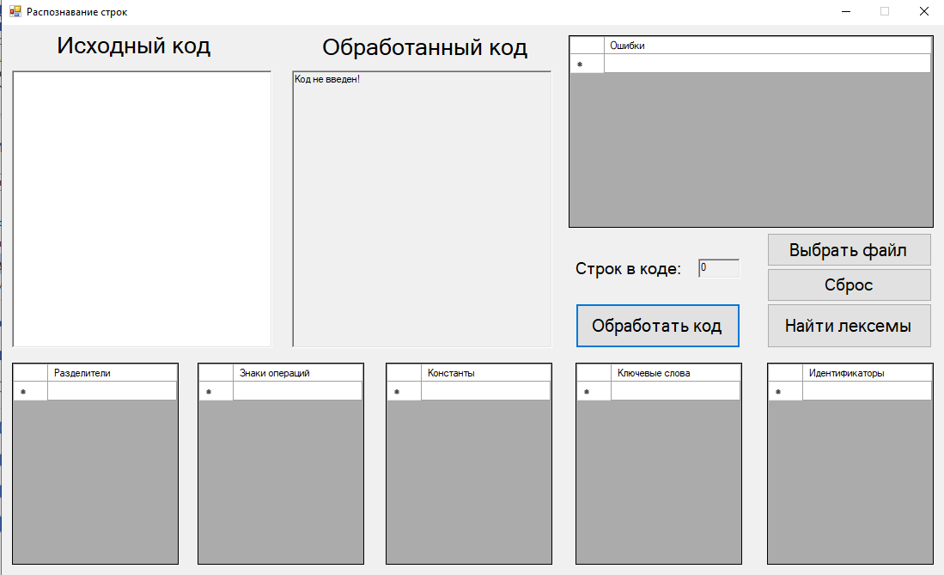

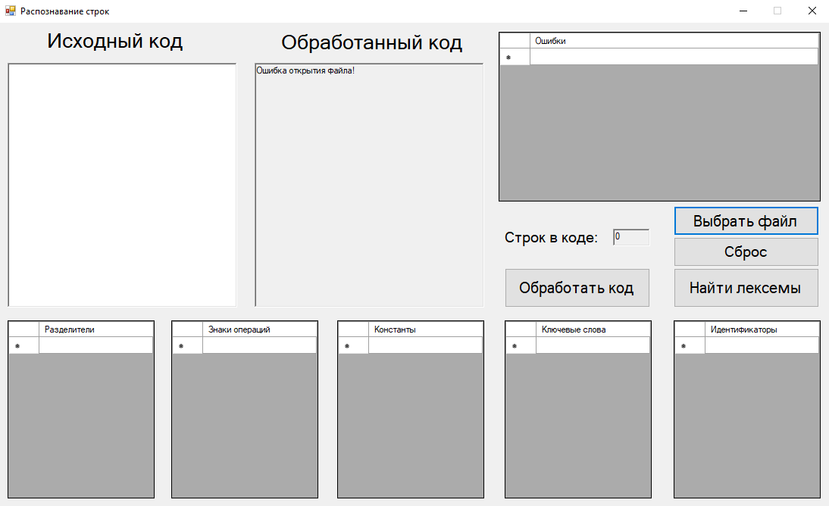

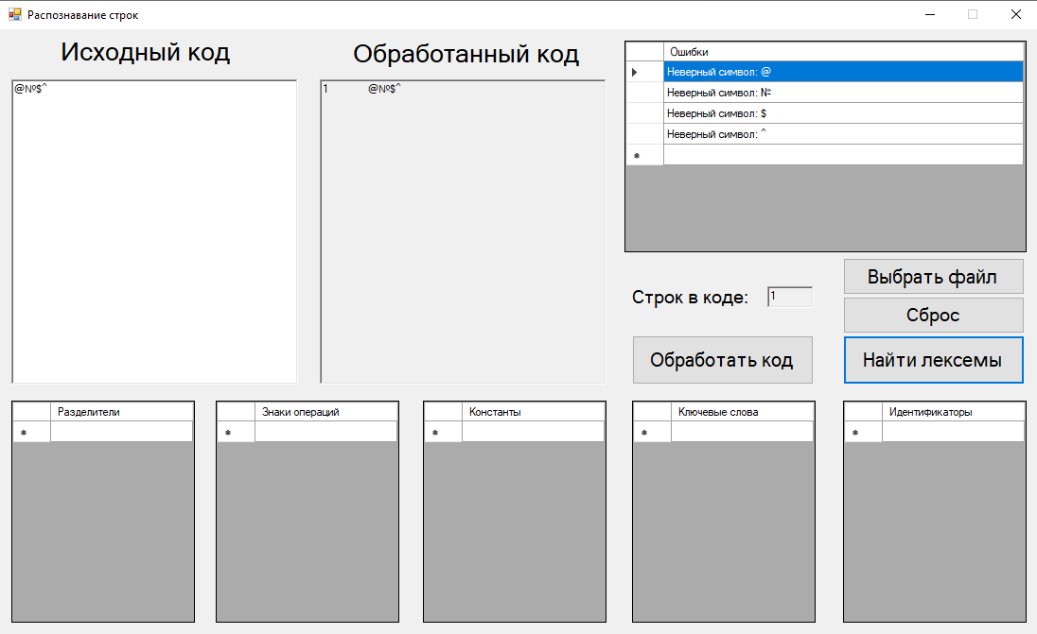

4. Программный код

bool search(DataGridView^ dataGridView, String^ symbol) {

for (int i = 0; i < dataGridView->RowCount; i++) {

if (dataGridView->Rows[i]->Cells->Count > 0) {

Object^ Cell = dataGridView->Rows[i]->Cells[0]->Value;

if (Cell != nullptr) {

String^ searchSymbol = Cell->ToString();

if (searchSymbol == symbol) return true;

}

}

}

if (symbol == "") return true;

else return false;

}

void Automat2(char c, int& s, string& str, int& i, bool& f) {

switch (s) {

case 0: {

switch (c) {

//пробел, перенос

case ' ':

case '\n': break;

//запрещенные символы

case '@':

case '`':

case '№':

case '$':

case '^': {

str += c;

f = true;

}

break;

//разделители

case '{':

case '}':

case '(':

case ')':

case '[':

case ']':

case ';':

case ',':

case ':': {

str += c;

s = 1;

f = true;

}

break;

//знаки

case '+': {

str += c;

s = 2;

}

break;

case '-': {

str += c;

s = 3;

}

break;

case '<': {

str += c;

s = 4;

}

break;

case '>': {

str += c;

s = 5;

}

break;

case '=':

case '*':

case '/':

case '%':

case '!': {

str += c;

s = 6;

}

break;

case '&': {

str += c;

s = 8;

}

break;

case '|': {

str += c;

s = 9;

}

break;

//константы

case '0':

case '1':

case '2':

case '3':

case '4':

case '5':

case '6':

case '7':

case '8':

case '9': {

str += c;

s = 10;

}

break;

/*case '\'': {

del += c;

s = 14;

}

break;

case '"': {

del += c;

s = 17;

}

break;*/

//ключевые слова

case 'a': {

str += c;

s = 14;

}

break;

case 'b': {

str += c;

s = 18;

}

break;

case 'c': {

str += c;

s = 24;

}

break;

case 'd': {

str += c;

s = 40;

}

break;

case 'e': {

str += c;

s = 53;

}

break;

case 'f': {

str += c;

s = 65;

}

break;

case 'g': {

str += c;

s = 77;

}

break;

case 'i': {

str += c;

s = 80;

}

break;

case 'l': {

str += c;

s = 85;

}

break;

case 'm': {

str += c;

s = 88;

}

break;

case 'n': {

str += c;

s = 94;

}

break;

case 'o': {

str += c;

s = 108;

}

break;

case 'p': {

str += c;

s = 115;

}

break;

case 'r': {

str += c;

s = 131;

}

break;

case 's': {

str += c;

s = 136;

}

break;

case 't': {

str += c;

s = 158;

}

break;

case 'u': {

str += c;

s = 171;

}

break;

case 'v': {

str += c;

s = 183;

}

break;

case 'w': {

str += c;

s = 191;

}

break;

case 'h':

case 'j':

case 'k':

case 'q':

case 'x':

case 'y':

case 'z':

case '_': {

str += c;

s = 999;

}

}

if (c >= 'A' && c <= 'Z') {

str += c;

s = 999;

}

}

break;

case 1:

break;

case 2: {

switch (c) {

case '+':

case '=': {

str += c;

s = 7;

f = true;

}

break;

default: {

i--;

f = true;

}

break;

}

}

break;

case 3: {

switch (c) {

case '-':

case '=': {

str += c;

s = 7;

f = true;

}

break;

default: {

i--;

f = true;

}

break;

}

}

break;

case 4: {

switch (c) {

case '<':

case '=': {

str += c;

s = 7;

f = true;

}

break;

default: {

i--;

f = true;

}

break;

}

}

break;

case 5: {

switch (c) {

case '>':

case '=': {

str += c;

s = 7;

f = true;

}

break;

default: {

i--;

f = true;

}

break;

}

}

break;

case 6: {

switch (c) {

case '=': {

str += c;

s = 7;

f = true;

}

break;

default: {

i--;

f = true;

}

break;

}

}

break;

case 7:

break;

case 8: {

switch (c) {

case '&': {

str += c;

s = 7;

f = true;

}

break;

default: {

i--;

f = true;

}

break;

}

}

break;

case 9: {

switch (c) {

case '|': {

str += c;

s = 7;

f = true;

}

break;

default: {

i--;

f = true;

}

break;

}

}

break;

case 10: {

switch (c) {

case '0':

case '1':

case '2':

case '3':

case '4':

case '5':

case '6':

case '7':

case '8':

case '9': {

str += c;

}

break;

case '.': {

str += c;

s = 11;

}

break;

case 'e':

case 'E': {

str += c;

s = 12;

}

break;

default: {

i--;

f = true;

}

break;

}

}

break;

case 11: {

switch (c) {

case '0':

case '1':

case '2':

case '3':

case '4':

case '5':

case '6':

case '7':

case '8':

case '9': {

str += c;

}

break;

case 'e':

case 'E': {

str += c;

s = 12;

}

break;

default: {

i--;

f = true;

}

break;

}

}

break;

case 12: {

switch (c) {

case '+':

case '-': {

str += c;

s = 13;

}

break;

default: {

i--;

f = true;

}

break;

}

}

break;

case 13: {

switch (c) {

case '0':

case '1':

case '2':

case '3':

case '4':

case '5':

case '6':

case '7':

case '8':

case '9': {

str += c;

}

break;

default: {

i--;

f = true;

}

break;

}

}

break;

case 14: {

switch (c) {

case 'u': {

str += c;

s = 15;

}

break;

default: {

if ((c >= 'A' && c <= 'Z') || (c >= 'a' && c <= 'z') || (c >= '0' && c <= '9') || c == '_') {

str += c;

s = 999;

}

else {

s = 999;

i--;

f = true;

}

}

break;

}

}

break;

case 15: {

switch (c) {

case 't': {

str += c;

s = 16;

}

break;

default: {

if ((c >= 'A' && c <= 'Z') || (c >= 'a' && c <= 'z') || (c >= '0' && c <= '9') || c == '_') {

str += c;

s = 999;

}

else {

s = 999;

i--;

f = true;

}

}

break;

}

}

break;

case 16: {

switch (c) {

case 'o': {

str += c;

s = 17;

}

break;

default: {

if ((c >= 'A' && c <= 'Z') || (c >= 'a' && c <= 'z') || (c >= '0' && c <= '9') || c == '_') {

str += c;

s = 999;

}

else {

s = 999;

i--;

f = true;

}

}

break;

}

}

break;

case 17: {

if ((c >= 'A' && c <= 'Z') || (c >= 'a' && c <= 'z') || (c >= '0' && c <= '9') || c == '_') {

str += c;

s = 999;

}

else {

i--;

f = true;

}

}

break;

case 18: {

switch (c) {

case 'o': {

str += c;

s = 19;

}

break;

case 'r': {

str += c;

s = 21;

}

break;

default: {

if ((c >= 'A' && c <= 'Z') || (c >= 'a' && c <= 'z') || (c >= '0' && c <= '9') || c == '_') {

str += c;

s = 999;

}

else {

s = 999;

i--;

f = true;

}

}

break;

}

}

break;

case 19: {

switch (c) {

case 'o': {

str += c;

s = 20;

}

break;

default: {

if ((c >= 'A' && c <= 'Z') || (c >= 'a' && c <= 'z') || (c >= '0' && c <= '9') || c == '_') {

str += c;

s = 999;

}

else {

s = 999;

i--;

f = true;

}

}

break;

}

}

break;

case 20: {

switch (c) {

case 'l': {

str += c;

s = 17;

}

break;

default: {

if ((c >= 'A' && c <= 'Z') || (c >= 'a' && c <= 'z') || (c >= '0' && c <= '9') || c == '_') {

str += c;

s = 999;

}

else {

s = 999;

i--;

f = true;

}

}

break;

}

}

break;

case 21: {

switch (c) {

case 'e': {

str += c;

s = 22;

}

break;

default: {

if ((c >= 'A' && c <= 'Z') || (c >= 'a' && c <= 'z') || (c >= '0' && c <= '9') || c == '_') {

str += c;

s = 999;

}

else {

s = 999;

i--;

f = true;

}

}

break;

}

}

break;

case 22: {

switch (c) {

case 'a': {

str += c;

s = 23;

}

break;

default: {

if ((c >= 'A' && c <= 'Z') || (c >= 'a' && c <= 'z') || (c >= '0' && c <= '9') || c == '_') {

str += c;

s = 999;

}

else {

s = 999;

i--;

f = true;

}

}

break;

}

}

break;

case 23: {

switch (c) {

case 'k': {

str += c;

s = 17;

}

break;

default: {

if ((c >= 'A' && c <= 'Z') || (c >= 'a' && c <= 'z') || (c >= '0' && c <= '9') || c == '_') {

str += c;

s = 999;

}

else {

s = 999;

i--;

f = true;

}

}

break;

}

}

break;

case 24: {

switch (c) {

case 'a': {

str += c;

s = 25;

}

break;

case 'h': {

str += c;

s = 29;

}

break;

case 'l': {

str += c;

s = 31;

}

break;

case 'o': {

str += c;

s = 34;

}

break;

default: {

if ((c >= 'A' && c <= 'Z') || (c >= 'a' && c <= 'z') || (c >= '0' && c <= '9') || c == '_') {

str += c;

s = 999;

}

else {

s = 999;

i--;

f = true;

}

}

break;

}

}

break;

case 25: {

switch (c) {

case 's': {

str += c;

s = 26;

}

break;

case 't': {

str += c;

s = 27;

}

break;

default: {

if ((c >= 'A' && c <= 'Z') || (c >= 'a' && c <= 'z') || (c >= '0' && c <= '9') || c == '_') {

str += c;

s = 999;

}

else {

s = 999;

i--;

f = true;

}

}

break;

}

}

break;

case 26: {

switch (c) {

case 'e': {

str += c;

s = 17;

}

break;

default: {

if ((c >= 'A' && c <= 'Z') || (c >= 'a' && c <= 'z') || (c >= '0' && c <= '9') || c == '_') {

str += c;

s = 999;

}

else {

s = 999;

i--;

f = true;

}

}

break;

}

}

break;

case 27: {

switch (c) {

case 'c': {

str += c;

s = 28;

}

break;

default: {

if ((c >= 'A' && c <= 'Z') || (c >= 'a' && c <= 'z') || (c >= '0' && c <= '9') || c == '_') {

str += c;

s = 999;

}

else {

s = 999;

i--;

f = true;

}

}

break;

}

}

break;

case 28: {

switch (c) {

case 'h': {

str += c;

s = 17;

}

break;

default: {

if ((c >= 'A' && c <= 'Z') || (c >= 'a' && c <= 'z') || (c >= '0' && c <= '9') || c == '_') {

str += c;

s = 999;

}

else {

s = 999;

i--;

f = true;

}

}

break;

}

}

break;

case 29: {

switch (c) {

case 'a': {

str += c;

s = 30;

}

break;

default: {

if ((c >= 'A' && c <= 'Z') || (c >= 'a' && c <= 'z') || (c >= '0' && c <= '9') || c == '_') {

str += c;

s = 999;

}

else {

s = 999;

i--;

f = true;

}

}

break;

}

}

break;

case 30: {

switch (c) {

case 'r': {

str += c;

s = 17;

}

break;

default: {

if ((c >= 'A' && c <= 'Z') || (c >= 'a' && c <= 'z') || (c >= '0' && c <= '9') || c == '_') {

str += c;

s = 999;

}

else {

s = 999;

i--;

f = true;

}

}

break;

}

}

break;

case 31: {

switch (c) {

case 'a': {

str += c;

s = 32;

}

break;

default: {

if ((c >= 'A' && c <= 'Z') || (c >= 'a' && c <= 'z') || (c >= '0' && c <= '9') || c == '_') {

str += c;

s = 999;

}

else {

s = 999;

i--;

f = true;

}

}

break;

}

}

break;

case 32: {

switch (c) {

case 's': {

str += c;

s = 33;

}

break;

default: {

if ((c >= 'A' && c <= 'Z') || (c >= 'a' && c <= 'z') || (c >= '0' && c <= '9') || c == '_') {

str += c;

s = 999;

}

else {

s = 999;

i--;

f = true;

}

}

break;

}

}

break;

case 33: {

switch (c) {

case 's': {

str += c;

s = 17;

}

break;

default: {

if ((c >= 'A' && c <= 'Z') || (c >= 'a' && c <= 'z') || (c >= '0' && c <= '9') || c == '_') {

str += c;

s = 999;

}

else {

s = 999;

i--;

f = true;

}

}

break;

}

}

break;

case 34: {

switch (c) {

case 'n': {

str += c;

s = 35;

}

break;

default: {

if ((c >= 'A' && c <= 'Z') || (c >= 'a' && c <= 'z') || (c >= '0' && c <= '9') || c == '_') {

str += c;

s = 999;

}

else {

s = 999;

i--;

f = true;

}

}

break;

}

}

break;

case 35: {

switch (c) {

case 'c': {

str += c;

s = 36;

}

break;

case 's': {

str += c;

s = 39;

}

break;

default: {

if ((c >= 'A' && c <= 'Z') || (c >= 'a' && c <= 'z') || (c >= '0' && c <= '9') || c == '_') {

str += c;

s = 999;

}

else {

s = 999;

i--;

f = true;

}

}

break;

}

}

break;

case 36: {

switch (c) {

case 'e': {

str += c;

s = 37;

}

break;

default: {

if ((c >= 'A' && c <= 'Z') || (c >= 'a' && c <= 'z') || (c >= '0' && c <= '9') || c == '_') {

str += c;

s = 999;

}

else {

s = 999;

i--;

f = true;

}

}

break;

}

}

break;

case 37: {

switch (c) {

case 'p': {

str += c;

s = 38;

}

break;

default: {

if ((c >= 'A' && c <= 'Z') || (c >= 'a' && c <= 'z') || (c >= '0' && c <= '9') || c == '_') {

str += c;

s = 999;

}

else {

s = 999;

i--;

f = true;

}

}

break;

}

}

break;

case 38: {

switch (c) {

case 't': {

str += c;

s = 17;

}

break;

default: {

if ((c >= 'A' && c <= 'Z') || (c >= 'a' && c <= 'z') || (c >= '0' && c <= '9') || c == '_') {

str += c;

s = 999;

}

else {

s = 999;

i--;

f = true;

}

}

break;

}

}

break;

case 39: {

switch (c) {

case 't': {

str += c;

s = 17;

}

break;

default: {

if ((c >= 'A' && c <= 'Z') || (c >= 'a' && c <= 'z') || (c >= '0' && c <= '9') || c == '_') {

str += c;

s = 999;

}

else {

s = 999;

i--;

f = true;

}

}

break;

}

}

break;

case 40: {

switch (c) {

case 'e': {

str += c;

s = 41;

}

break;

case 'o': {

str += c;

s = 49;

}

break;

default: {

if ((c >= 'A' && c <= 'Z') || (c >= 'a' && c <= 'z') || (c >= '0' && c <= '9') || c == '_') {

str += c;

s = 999;

}

else {

s = 999;

i--;

f = true;

}

}

break;

}

}

break;

case 41: {

switch (c) {

case 'f': {

str += c;

s = 42;

}

break;

case 'l': {

str += c;

s = 46;

}

break;

default: {

if ((c >= 'A' && c <= 'Z') || (c >= 'a' && c <= 'z') || (c >= '0' && c <= '9') || c == '_') {

str += c;

s = 999;

}

else {

s = 999;

i--;

f = true;

}

}

break;

}

}

break;

case 42: {

switch (c) {

case 'a': {

str += c;

s = 43;

}

break;

default: {

if ((c >= 'A' && c <= 'Z') || (c >= 'a' && c <= 'z') || (c >= '0' && c <= '9') || c == '_') {

str += c;

s = 999;

}

else {

s = 999;

i--;

f = true;

}

}

break;

}

}

break;

case 43: {

switch (c) {

case 'u': {

str += c;

s = 44;

}

break;

default: {

if ((c >= 'A' && c <= 'Z') || (c >= 'a' && c <= 'z') || (c >= '0' && c <= '9') || c == '_') {

str += c;

s = 999;

}

else {

s = 999;

i--;

f = true;

}

}

break;

}

}

break;

case 44: {

switch (c) {

case 'l': {

str += c;

s = 45;

}

break;

default: {

if ((c >= 'A' && c <= 'Z') || (c >= 'a' && c <= 'z') || (c >= '0' && c <= '9') || c == '_') {

str += c;

s = 999;

}

else {

s = 999;

i--;

f = true;

}

}

break;

}

}

break;

case 45: {

switch (c) {

case 't': {

str += c;

s = 17;

}

break;

default: {

if ((c >= 'A' && c <= 'Z') || (c >= 'a' && c <= 'z') || (c >= '0' && c <= '9') || c == '_') {

str += c;

s = 999;

}

else {

s = 999;

i--;

f = true;

}

}

break;

}

}

break;

case 46: {

switch (c) {

case 'e': {

str += c;

s = 47;

}

break;

default: {

if ((c >= 'A' && c <= 'Z') || (c >= 'a' && c <= 'z') || (c >= '0' && c <= '9') || c == '_') {

str += c;

s = 999;

}

else {

s = 999;

i--;

f = true;

}

}

break;

}

}

break;

case 47: {

switch (c) {

case 't': {

str += c;

s = 48;

}

break;

default: {

if ((c >= 'A' && c <= 'Z') || (c >= 'a' && c <= 'z') || (c >= '0' && c <= '9') || c == '_') {

str += c;

s = 999;

}

else {

s = 999;

i--;

f = true;

}

}

break;

}

}

break;

case 48: {

switch (c) {

case 'e': {

str += c;

s = 17;

}

break;

default: {

if ((c >= 'A' && c <= 'Z') || (c >= 'a' && c <= 'z') || (c >= '0' && c <= '9') || c == '_') {

str += c;

s = 999;

}

else {

s = 999;

i--;

f = true;

}

}

break;

}

}

break;

case 49: {

switch (c) {

case 'u': {

str += c;

s = 50;

}

break;

default: {

if ((c >= 'A' && c <= 'Z') || (c >= 'a' && c <= 'z') || (c >= '0' && c <= '9') || c == '_') {

str += c;

s = 999;

}

else {

s = 17;

i--;

f = true;

}

}

break;

}

}

break;

case 50: {

switch (c) {

case 'b': {

str += c;

s = 51;

}

break;

default: {

if ((c >= 'A' && c <= 'Z') || (c >= 'a' && c <= 'z') || (c >= '0' && c <= '9') || c == '_') {

str += c;

s = 999;

}

else {

s = 999;

i--;

f = true;

}

}

break;

}

}

break;

case 51: {

switch (c) {

case 'l': {

str += c;

s = 52;

}

break;

default: {

if ((c >= 'A' && c <= 'Z') || (c >= 'a' && c <= 'z') || (c >= '0' && c <= '9') || c == '_') {

str += c;

s = 999;

}

else {

s = 999;

i--;

f = true;

}

}

break;

}

}

break;

case 52: {

switch (c) {

case 'e': {

str += c;

s = 17;

}

break;

default: {

if ((c >= 'A' && c <= 'Z') || (c >= 'a' && c <= 'z') || (c >= '0' && c <= '9') || c == '_') {

str += c;

s = 999;

}

else {

s = 999;

i--;

f = true;

}

}

break;

}

}

break;

case 53: {

switch (c) {

case 'l': {

str += c;

s = 54;

}

break;

case 'n': {

str += c;

s = 56;

}

break;

case 'x': {

str += c;

s = 58;

}

break;

default: {

if ((c >= 'A' && c <= 'Z') || (c >= 'a' && c <= 'z') || (c >= '0' && c <= '9') || c == '_') {

str += c;

s = 999;

}

else {

s = 999;

i--;

f = true;

}

}

break;

}

}

break;

case 54: {

switch (c) {

case 's': {

str += c;

s = 55;

}

break;

default: {

if ((c >= 'A' && c <= 'Z') || (c >= 'a' && c <= 'z') || (c >= '0' && c <= '9') || c == '_') {

str += c;

s = 999;

}

else {

s = 999;

i--;

f = true;

}

}

break;

}

}

break;

case 55: {

switch (c) {

case 'e': {

str += c;

s = 17;

}

break;

default: {

if ((c >= 'A' && c <= 'Z') || (c >= 'a' && c <= 'z') || (c >= '0' && c <= '9') || c == '_') {

str += c;

s = 999;

}

else {

s = 999;

i--;

f = true;

}

}

break;

}

}

break;

case 56: {

switch (c) {

case 'u': {

str += c;

s = 57;

}

break;

default: {

if ((c >= 'A' && c <= 'Z') || (c >= 'a' && c <= 'z') || (c >= '0' && c <= '9') || c == '_') {

str += c;

s = 999;

}

else {

s = 999;

i--;

f = true;

}

}

break;

}

}

break;

case 57: {

switch (c) {

case 'm': {

str += c;

s = 17;

}

break;

default: {

if ((c >= 'A' && c <= 'Z') || (c >= 'a' && c <= 'z') || (c >= '0' && c <= '9') || c == '_') {

str += c;

s = 999;

}

else {

s = 999;

i--;

f = true;

}

}

break;

}

}

break;

case 58: {

switch (c) {

case 'p': {

str += c;

s = 59;

}

break;

case 't': {

str += c;

s = 62;

}

break;

default: {

if ((c >= 'A' && c <= 'Z') || (c >= 'a' && c <= 'z') || (c >= '0' && c <= '9') || c == '_') {

str += c;

s = 999;

}

else {

s = 999;

i--;

f = true;

}

}

break;

}

}

break;

case 59: {

switch (c) {

case 'o': {

str += c;

s = 60;

}

break;

default: {

if ((c >= 'A' && c <= 'Z') || (c >= 'a' && c <= 'z') || (c >= '0' && c <= '9') || c == '_') {

str += c;

s = 999;

}

else {

s = 999;

i--;

f = true;

}

}

break;

}

}

break;

case 60: {

switch (c) {

case 'r': {

str += c;

s = 61;

}

break;

default: {

if ((c >= 'A' && c <= 'Z') || (c >= 'a' && c <= 'z') || (c >= '0' && c <= '9') || c == '_') {

str += c;

s = 999;

}

else {

s = 999;

i--;

f = true;

}

}

break;

}

}

break;

case 61: {

switch (c) {

case 't': {

str += c;

s = 17;

}

break;

default: {

if ((c >= 'A' && c <= 'Z') || (c >= 'a' && c <= 'z') || (c >= '0' && c <= '9') || c == '_') {

str += c;

s = 999;

}

else {

s = 999;

i--;

f = true;

}

}

break;

}

}

break;

case 62: {

switch (c) {

case 'e': {

str += c;

s = 63;

}

break;

default: {

if ((c >= 'A' && c <= 'Z') || (c >= 'a' && c <= 'z') || (c >= '0' && c <= '9') || c == '_') {

str += c;

s = 999;

}

else {

s = 999;

i--;

f = true;

}

}

break;

}

}

break;

case 63: {

switch (c) {

case 'r': {

str += c;

s = 64;

}

break;

default: {

if ((c >= 'A' && c <= 'Z') || (c >= 'a' && c <= 'z') || (c >= '0' && c <= '9') || c == '_') {

str += c;

s = 999;

}

else {

s = 999;

i--;

f = true;

}

}

break;

}

}

break;

case 64: {

switch (c) {

case 'n': {

str += c;

s = 17;

}

break;

default: {

if ((c >= 'A' && c <= 'Z') || (c >= 'a' && c <= 'z') || (c >= '0' && c <= '9') || c == '_') {

str += c;

s = 999;

}

else {

s = 999;

i--;

f = true;

}

}

break;

}

}

break;

case 65: {

switch (c) {

case 'a': {

str += c;

s = 66;

}

break;

case 'l': {

str += c;

s = 69;

}

break;

case 'o': {

str += c;

s = 72;

}

break;

case 'r': {

str += c;

s = 73;

}

break;

default: {

if ((c >= 'A' && c <= 'Z') || (c >= 'a' && c <= 'z') || (c >= '0' && c <= '9') || c == '_') {

str += c;

s = 999;

}

else {

s = 999;

i--;

f = true;

}

}

break;

}

}

break;

case 66: {

switch (c) {

case 'l': {

str += c;

s = 67;

}

break;

default: {

if ((c >= 'A' && c <= 'Z') || (c >= 'a' && c <= 'z') || (c >= '0' && c <= '9') || c == '_') {

str += c;

s = 999;

}

else {

s = 999;

i--;

f = true;

}

}

break;

}

}

break;

case 67: {

switch (c) {

case 's': {

str += c;

s = 68;

}

break;

default: {

if ((c >= 'A' && c <= 'Z') || (c >= 'a' && c <= 'z') || (c >= '0' && c <= '9') || c == '_') {

str += c;

s = 999;

}

else {

s = 999;

i--;

f = true;

}

}

break;

}

}

break;

case 68: {

switch (c) {

case 'e': {

str += c;

s = 17;

}

break;

default: {

if ((c >= 'A' && c <= 'Z') || (c >= 'a' && c <= 'z') || (c >= '0' && c <= '9') || c == '_') {

str += c;

s = 999;

}

else {

s = 999;

i--;

f = true;

}

}

break;

}

}

break;

case 69: {

switch (c) {

case 'o': {

str += c;

s = 70;

}

break;

default: {

if ((c >= 'A' && c <= 'Z') || (c >= 'a' && c <= 'z') || (c >= '0' && c <= '9') || c == '_') {

str += c;

s = 999;

}

else {

s = 999;

i--;

f = true;

}

}

break;

}

}

break;

case 70: {

switch (c) {

case 'a': {

str += c;

s = 71;

}

break;

default: {

if ((c >= 'A' && c <= 'Z') || (c >= 'a' && c <= 'z') || (c >= '0' && c <= '9') || c == '_') {

str += c;

s = 999;

}

else {

s = 999;

i--;

f = true;

}

}

break;

}

}

break;

case 71: {

switch (c) {

case 't': {

str += c;

s = 17;

}

break;

default: {

if ((c >= 'A' && c <= 'Z') || (c >= 'a' && c <= 'z') || (c >= '0' && c <= '9') || c == '_') {

str += c;

s = 999;

}

else {

s = 999;

i--;

f = true;

}

}

break;

}

}

break;

case 72: {

switch (c) {

case 'r': {

str += c;

s = 17;

}

break;

default: {

if ((c >= 'A' && c <= 'Z') || (c >= 'a' && c <= 'z') || (c >= '0' && c <= '9') || c == '_') {

str += c;

s = 999;

}

else {

s = 999;

i--;

f = true;

}

}

break;

}

}

break;

case 73: {

switch (c) {

case 'i': {

str += c;

s = 74;

}

break;

default: {

if ((c >= 'A' && c <= 'Z') || (c >= 'a' && c <= 'z') || (c >= '0' && c <= '9') || c == '_') {

str += c;

s = 999;

}

else {

s = 999;

i--;

f = true;

}

}

break;

}

}

break;

case 74: {

switch (c) {

case 'e': {

str += c;

s = 75;

}

break;

default: {

if ((c >= 'A' && c <= 'Z') || (c >= 'a' && c <= 'z') || (c >= '0' && c <= '9') || c == '_') {

str += c;

s = 999;

}

else {

s = 999;

i--;

f = true;

}

}

break;

}

}

break;

case 75: {

switch (c) {

case 'n': {

str += c;

s = 76;

}

break;

default: {

if ((c >= 'A' && c <= 'Z') || (c >= 'a' && c <= 'z') || (c >= '0' && c <= '9') || c == '_') {

str += c;

s = 999;

}

else {

s = 999;

i--;

f = true;

}

}

break;

}

}

break;

case 76: {

switch (c) {

case 'd': {

str += c;

s = 17;

}

break;

default: {

if ((c >= 'A' && c <= 'Z') || (c >= 'a' && c <= 'z') || (c >= '0' && c <= '9') || c == '_') {

str += c;

s = 999;

}

else {

s = 999;

i--;

f = true;

}

}

break;

}

}

break;

case 77: {

switch (c) {

case 'o': {

str += c;

s = 78;

}

break;

default: {

if ((c >= 'A' && c <= 'Z') || (c >= 'a' && c <= 'z') || (c >= '0' && c <= '9') || c == '_') {

str += c;

s = 999;

}

else {

s = 999;

i--;

f = true;

}

}

break;

}

}

break;

case 78: {

switch (c) {

case 't': {

str += c;

s = 79;

}

break;

default: {

if ((c >= 'A' && c <= 'Z') || (c >= 'a' && c <= 'z') || (c >= '0' && c <= '9') || c == '_') {

str += c;

s = 999;

}

else {

s = 999;

i--;

f = true;

}

}

break;

}

}

break;

case 79: {

switch (c) {

case 'o': {

str += c;

s = 17;

}

break;

default: {

if ((c >= 'A' && c <= 'Z') || (c >= 'a' && c <= 'z') || (c >= '0' && c <= '9') || c == '_') {

str += c;

s = 999;

}

else {

s = 999;

i--;

f = true;

}

}

break;

}

}

break;

case 80: {

switch (c) {

case 'f': {

str += c;

s = 17;

}

break;

case 'n': {

str += c;

s = 81;

}

break;

default: {

if ((c >= 'A' && c <= 'Z') || (c >= 'a' && c <= 'z') || (c >= '0' && c <= '9') || c == '_') {

str += c;

s = 999;

}

else {

s = 999;

i--;

f = true;

}

}

break;

}

}

break;

case 81: {

switch (c) {

case 'l': {

str += c;

s = 82;

}

break;

case 't': {

str += c;

s = 17;

}

break;

default: {

if ((c >= 'A' && c <= 'Z') || (c >= 'a' && c <= 'z') || (c >= '0' && c <= '9') || c == '_') {

str += c;

s = 999;

}

else {

s = 999;

i--;

f = true;

}

}

break;

}

}

break;

case 82: {

switch (c) {

case 'i': {

str += c;

s = 83;

}

break;

default: {

if ((c >= 'A' && c <= 'Z') || (c >= 'a' && c <= 'z') || (c >= '0' && c <= '9') || c == '_') {

str += c;

s = 999;

}

else {

s = 999;

i--;

f = true;

}

}

break;

}

}

break;

case 83: {

switch (c) {

case 'n': {

str += c;

s = 84;

}

break;

default: {

if ((c >= 'A' && c <= 'Z') || (c >= 'a' && c <= 'z') || (c >= '0' && c <= '9') || c == '_') {

str += c;

s = 999;

}

else {

s = 999;

i--;

f = true;

}

}

break;

}

}

break;

case 84: {

switch (c) {

case 'e': {

str += c;

s = 17;

}

break;

default: {

if ((c >= 'A' && c <= 'Z') || (c >= 'a' && c <= 'z') || (c >= '0' && c <= '9') || c == '_') {

str += c;

s = 999;

}

else {

s = 999;

i--;

f = true;

}

}

break;

}

}

break;

case 85: {

switch (c) {

case 'o': {

str += c;

s = 86;

}

break;

default: {

if ((c >= 'A' && c <= 'Z') || (c >= 'a' && c <= 'z') || (c >= '0' && c <= '9') || c == '_') {

str += c;

s = 999;

}

else {

s = 999;

i--;

f = true;

}

}

break;

}

}

break;

case 86: {

switch (c) {

case 'n': {

str += c;

s = 87;

}

break;

default: {

if ((c >= 'A' && c <= 'Z') || (c >= 'a' && c <= 'z') || (c >= '0' && c <= '9') || c == '_') {

str += c;

s = 999;

}

else {

s = 999;

i--;

f = true;

}

}

break;

}

}

break;

case 87: {

switch (c) {

case 'g': {

str += c;

s = 17;

}

break;

default: {

if ((c >= 'A' && c <= 'Z') || (c >= 'a' && c <= 'z') || (c >= '0' && c <= '9') || c == '_') {

str += c;

s = 999;

}

else {

s = 999;

i--;

f = true;

}

}

break;

}

}

break;

case 88: {

switch (c) {

case 'u': {

str += c;

s = 89;

}

break;

default: {

if ((c >= 'A' && c <= 'Z') || (c >= 'a' && c <= 'z') || (c >= '0' && c <= '9') || c == '_') {

str += c;

s = 999;

}

else {

s = 999;

i--;

f = true;

}

}

break;

}

}

break;

case 89: {

switch (c) {

case 't': {

str += c;

s = 90;

}

break;

default: {

if ((c >= 'A' && c <= 'Z') || (c >= 'a' && c <= 'z') || (c >= '0' && c <= '9') || c == '_') {

str += c;

s = 999;

}

else {

s = 999;

i--;

f = true;

}

}

break;

}

}

break;

case 90: {

switch (c) {

case 'a': {

str += c;

s = 91;

}

break;

default: {

if ((c >= 'A' && c <= 'Z') || (c >= 'a' && c <= 'z') || (c >= '0' && c <= '9') || c == '_') {

str += c;

s = 999;

}

else {

s = 999;

i--;

f = true;

}

}

break;

}

}

break;

case 91: {

switch (c) {

case 'b': {

str += c;

s = 92;

}

break;

default: {

if ((c >= 'A' && c <= 'Z') || (c >= 'a' && c <= 'z') || (c >= '0' && c <= '9') || c == '_') {

str += c;

s = 999;

}

else {

s = 999;

i--;

f = true;

}

}

break;

}

}

break;

case 92: {

switch (c) {

case 'l': {

str += c;

s = 93;

}

break;

default: {

if ((c >= 'A' && c <= 'Z') || (c >= 'a' && c <= 'z') || (c >= '0' && c <= '9') || c == '_') {

str += c;

s = 999;

}

else {

s = 999;

i--;

f = true;

}

}

break;

}

}

break;

case 93: {

switch (c) {

case 'e': {

str += c;

s = 17;

}

break;

default: {

if ((c >= 'A' && c <= 'Z') || (c >= 'a' && c <= 'z') || (c >= '0' && c <= '9') || c == '_') {

str += c;

s = 999;

}

else {

s = 999;

i--;

f = true;

}

}

break;

}

}

break;

case 94: {

switch (c) {

case 'a': {

str += c;

s = 95;

}

break;

case 'e': {

str += c;

s = 102;

}

break;

case 'u': {

str += c;

s = 103;

}

break;

default: {

if ((c >= 'A' && c <= 'Z') || (c >= 'a' && c <= 'z') || (c >= '0' && c <= '9') || c == '_') {

str += c;

s = 999;

}

else {

s = 999;

i--;

f = true;

}

}

break;

}

}

break;

case 95: {

switch (c) {

case 'm': {

str += c;

s = 96;

}

break;

default: {

if ((c >= 'A' && c <= 'Z') || (c >= 'a' && c <= 'z') || (c >= '0' && c <= '9') || c == '_') {

str += c;

s = 999;

}

else {

s = 999;

i--;

f = true;

}

}

break;

}

}

break;

case 96: {

switch (c) {

case 'e': {

str += c;

s = 97;

}

break;

default: {

if ((c >= 'A' && c <= 'Z') || (c >= 'a' && c <= 'z') || (c >= '0' && c <= '9') || c == '_') {

str += c;

s = 999;

}

else {

s = 999;

i--;

f = true;

}

}

break;

}

}

break;

case 97: {

switch (c) {

case 's': {

str += c;

s = 98;

}

break;

default: {

if ((c >= 'A' && c <= 'Z') || (c >= 'a' && c <= 'z') || (c >= '0' && c <= '9') || c == '_') {

str += c;

s = 999;

}

else {

s = 999;

i--;

f = true;

}

}

break;

}

}

break;

case 98: {

switch (c) {

case 'p': {

str += c;

s = 99;

}

break;

default: {

if ((c >= 'A' && c <= 'Z') || (c >= 'a' && c <= 'z') || (c >= '0' && c <= '9') || c == '_') {

str += c;

s = 999;

}

else {

s = 999;

i--;

f = true;

}

}

break;

}

}

break;

case 99: {

switch (c) {

case 'a': {

str += c;

s = 100;

}

break;

default: {

if ((c >= 'A' && c <= 'Z') || (c >= 'a' && c <= 'z') || (c >= '0' && c <= '9') || c == '_') {

str += c;

s = 999;

}

else {

s = 999;

i--;

f = true;

}

}

break;

}

}

break;

case 100: {

switch (c) {

case 'c': {

str += c;

s = 101;

}

break;

default: {

if ((c >= 'A' && c <= 'Z') || (c >= 'a' && c <= 'z') || (c >= '0' && c <= '9') || c == '_') {

str += c;

s = 999;

}

else {

s = 999;

i--;

f = true;

}

}

break;

}

}

break;

case 101: {

switch (c) {

case 'e': {

str += c;

s = 17;

}

break;

default: {

if ((c >= 'A' && c <= 'Z') || (c >= 'a' && c <= 'z') || (c >= '0' && c <= '9') || c == '_') {

str += c;

s = 999;

}

else {

s = 999;

i--;

f = true;

}

}

break;

}

}

break;

case 102: {

switch (c) {

case 'w': {

str += c;

s = 17;

}

break;

default: {

if ((c >= 'A' && c <= 'Z') || (c >= 'a' && c <= 'z') || (c >= '0' && c <= '9') || c == '_') {

str += c;

s = 999;

}

else {

s = 999;

i--;

f = true;

}

}

break;

}

}

break;

case 103: {

switch (c) {

case 'l': {

str += c;

s = 104;

}

break;

default: {

if ((c >= 'A' && c <= 'Z') || (c >= 'a' && c <= 'z') || (c >= '0' && c <= '9') || c == '_') {

str += c;

s = 999;

}

else {

s = 999;

i--;

f = true;

}

}

break;

}

}

break;

case 104: {

switch (c) {

case 'l': {

str += c;

s = 105;

}

break;

default: {

if ((c >= 'A' && c <= 'Z') || (c >= 'a' && c <= 'z') || (c >= '0' && c <= '9') || c == '_') {

str += c;

s = 999;

}

else {

s = 999;

i--;

f = true;

}

}

break;

}

}

break;

case 105: {

switch (c) {

case 'p': {

str += c;

s = 106;

}

break;

default: {

if ((c >= 'A' && c <= 'Z') || (c >= 'a' && c <= 'z') || (c >= '0' && c <= '9') || c == '_') {

str += c;

s = 999;

}

else {

s = 999;

i--;

f = true;

}

}

break;

}

}

break;

case 106: {

switch (c) {

case 't': {

str += c;

s = 107;

}

break;

default: {

if ((c >= 'A' && c <= 'Z') || (c >= 'a' && c <= 'z') || (c >= '0' && c <= '9') || c == '_') {

str += c;

s = 999;

}

else {

s = 999;

i--;

f = true;

}

}

break;

}

}

break;

case 107: {

switch (c) {

case 'r': {

str += c;

s = 17;

}

break;

default: {

if ((c >= 'A' && c <= 'Z') || (c >= 'a' && c <= 'z') || (c >= '0' && c <= '9') || c == '_') {

str += c;

s = 999;

}

else {

s = 999;

i--;

f = true;

}

}

break;

}

}

break;

case 108: {

switch (c) {

case 'p': {

str += c;

s = 109;

}

break;

default: {

if ((c >= 'A' && c <= 'Z') || (c >= 'a' && c <= 'z') || (c >= '0' && c <= '9') || c == '_') {

str += c;

s = 999;

}

else {

s = 999;

i--;

f = true;

}

}

break;

}

}

break;

case 109: {

switch (c) {

case 'e': {

str += c;

s = 110;

}

break;

default: {

if ((c >= 'A' && c <= 'Z') || (c >= 'a' && c <= 'z') || (c >= '0' && c <= '9') || c == '_') {

str += c;

s = 999;

}

else {

s = 999;

i--;

f = true;

}

}

break;

}

}

break;

case 110: {

switch (c) {

case 'r': {

str += c;

s = 111;

}

break;

default: {

if ((c >= 'A' && c <= 'Z') || (c >= 'a' && c <= 'z') || (c >= '0' && c <= '9') || c == '_') {

str += c;

s = 999;

}

else {

s = 999;

i--;

f = true;

}

}

break;

}

}

break;

case 111: {

switch (c) {

case 'a': {

str += c;

s = 112;

}

break;

default: {

if ((c >= 'A' && c <= 'Z') || (c >= 'a' && c <= 'z') || (c >= '0' && c <= '9') || c == '_') {

str += c;

s = 999;

}

else {

s = 999;

i--;

f = true;

}

}

break;

}

}

break;

case 112: {

switch (c) {

case 't': {

str += c;

s = 113;

}

break;

default: {

if ((c >= 'A' && c <= 'Z') || (c >= 'a' && c <= 'z') || (c >= '0' && c <= '9') || c == '_') {

str += c;

s = 999;

}

else {

s = 999;

i--;

f = true;

}

}

break;

}

}

break;

case 113: {

switch (c) {

case 'o': {

str += c;

s = 114;

}

break;

default: {

if ((c >= 'A' && c <= 'Z') || (c >= 'a' && c <= 'z') || (c >= '0' && c <= '9') || c == '_') {

str += c;

s = 999;

}

else {

s = 999;

i--;

f = true;

}

}

break;

}

}

break;

case 114: {

switch (c) {

case 'r': {

str += c;

s = 17;

}

break;

default: {

if ((c >= 'A' && c <= 'Z') || (c >= 'a' && c <= 'z') || (c >= '0' && c <= '9') || c == '_') {

str += c;

s = 999;

}

else {

s = 999;

i--;

f = true;

}

}

break;

}

}

break;

case 115: {

switch (c) {

case 'r': {

str += c;

s = 116;

}

break;

case 'u': {

str += c;

s = 127;

}

break;

default: {

if ((c >= 'A' && c <= 'Z') || (c >= 'a' && c <= 'z') || (c >= '0' && c <= '9') || c == '_') {

str += c;

s = 999;

}

else {

s = 999;

i--;

f = true;

}

}

break;

}

}

break;

case 116: {

switch (c) {

case 'i': {

str += c;

s = 117;

}

break;

case 'o': {

str += c;

s = 121;

}

break;

default: {

if ((c >= 'A' && c <= 'Z') || (c >= 'a' && c <= 'z') || (c >= '0' && c <= '9') || c == '_') {

str += c;

s = 999;

}

else {

s = 999;

i--;

f = true;

}

}

break;

}

}

break;

case 117: {

switch (c) {

case 'v': {

str += c;

s = 118;

}

break;

default: {

if ((c >= 'A' && c <= 'Z') || (c >= 'a' && c <= 'z') || (c >= '0' && c <= '9') || c == '_') {

str += c;

s = 999;

}

else {

s = 999;

i--;

f = true;

}

}

break;

}

}

break;

case 118: {

switch (c) {

case 'a': {

str += c;

s = 119;

}

break;

default: {

if ((c >= 'A' && c <= 'Z') || (c >= 'a' && c <= 'z') || (c >= '0' && c <= '9') || c == '_') {

str += c;

s = 999;

}

else {

s = 999;

i--;

f = true;

}

}

break;

}

}

break;

case 119: {

switch (c) {

case 't': {

str += c;

s = 120;

}

break;

default: {

if ((c >= 'A' && c <= 'Z') || (c >= 'a' && c <= 'z') || (c >= '0' && c <= '9') || c == '_') {

str += c;

s = 999;

}

else {

s = 999;

i--;

f = true;

}

}

break;

}

}

break;

case 120: {

switch (c) {

case 'e': {

str += c;

s = 17;

}

break;

default: {

if ((c >= 'A' && c <= 'Z') || (c >= 'a' && c <= 'z') || (c >= '0' && c <= '9') || c == '_') {

str += c;

s = 999;

}

else {

s = 999;

i--;

f = true;

}

}

break;

}

}

break;

case 121: {

switch (c) {

case 't': {

str += c;

s = 122;

}

break;

default: {

if ((c >= 'A' && c <= 'Z') || (c >= 'a' && c <= 'z') || (c >= '0' && c <= '9') || c == '_') {

str += c;

s = 999;

}

else {

s = 999;

i--;

f = true;

}

}

break;

}

}

break;

case 122: {

switch (c) {

case 'e': {

str += c;

s = 123;

}

break;

default: {

if ((c >= 'A' && c <= 'Z') || (c >= 'a' && c <= 'z') || (c >= '0' && c <= '9') || c == '_') {

str += c;

s = 999;

}

else {

s = 999;

i--;

f = true;

}

}

break;

}

}

break;

case 123: {

switch (c) {

case 'c': {

str += c;

s = 124;

}

break;

default: {

if ((c >= 'A' && c <= 'Z') || (c >= 'a' && c <= 'z') || (c >= '0' && c <= '9') || c == '_') {

str += c;

s = 999;

}

else {

s = 999;

i--;

f = true;

}

}

break;

}

}

break;

case 124: {

switch (c) {

case 't': {

str += c;

s = 125;

}

break;

default: {

if ((c >= 'A' && c <= 'Z') || (c >= 'a' && c <= 'z') || (c >= '0' && c <= '9') || c == '_') {

str += c;

s = 999;

}

else {

s = 999;

i--;

f = true;

}

}

break;

}

}

break;

case 125: {

switch (c) {

case 'e': {

str += c;

s = 126;

}

break;

default: {

if ((c >= 'A' && c <= 'Z') || (c >= 'a' && c <= 'z') || (c >= '0' && c <= '9') || c == '_') {

str += c;

s = 999;

}

else {

s = 999;

i--;

f = true;

}

}

break;

}

}

break;

case 126: {

switch (c) {

case 'd': {

str += c;

s = 17;

}

break;

default: {

if ((c >= 'A' && c <= 'Z') || (c >= 'a' && c <= 'z') || (c >= '0' && c <= '9') || c == '_') {

str += c;

s = 999;

}

else {

s = 999;

i--;

f = true;

}

}

break;

}

}

break;

case 127: {

switch (c) {

case 'b': {

str += c;

s = 128;

}

break;

default: {

if ((c >= 'A' && c <= 'Z') || (c >= 'a' && c <= 'z') || (c >= '0' && c <= '9') || c == '_') {

str += c;

s = 999;

}

else {

s = 999;

i--;

f = true;

}

}

break;

}

}

break;

case 128: {

switch (c) {

case 'l': {

str += c;

s = 129;

}

break;

default: {

if ((c >= 'A' && c <= 'Z') || (c >= 'a' && c <= 'z') || (c >= '0' && c <= '9') || c == '_') {

str += c;

s = 999;

}

else {

s = 999;

i--;

f = true;

}

}

break;

}

}

break;

case 129: {

switch (c) {

case 'i': {

str += c;

s = 130;

}

break;

default: {

if ((c >= 'A' && c <= 'Z') || (c >= 'a' && c <= 'z') || (c >= '0' && c <= '9') || c == '_') {

str += c;

s = 999;

}

else {

s = 999;

i--;

f = true;

}

}

break;

}

}

break;

case 130: {

switch (c) {

case 'c': {

str += c;

s = 17;

}

break;

default: {

if ((c >= 'A' && c <= 'Z') || (c >= 'a' && c <= 'z') || (c >= '0' && c <= '9') || c == '_') {

str += c;

s = 999;

}

else {

s = 999;

i--;

f = true;

}

}

break;

}

}

break;

case 131: {

switch (c) {

case 'e': {

str += c;

s = 132;

}

break;

default: {

if ((c >= 'A' && c <= 'Z') || (c >= 'a' && c <= 'z') || (c >= '0' && c <= '9') || c == '_') {

str += c;

s = 999;

}

else {

s = 999;

i--;

f = true;

}

}

break;

}

}

break;

case 132: {

switch (c) {

case 't': {

str += c;

s = 133;

}

break;

default: {

if ((c >= 'A' && c <= 'Z') || (c >= 'a' && c <= 'z') || (c >= '0' && c <= '9') || c == '_') {

str += c;

s = 999;

}

else {

s = 999;

i--;

f = true;

}

}

break;

}

}

break;

case 133: {

switch (c) {

case 'u': {

str += c;

s = 134;

}

break;

default: {

if ((c >= 'A' && c <= 'Z') || (c >= 'a' && c <= 'z') || (c >= '0' && c <= '9') || c == '_') {

str += c;

s = 999;

}

else {

s = 999;

i--;

f = true;

}

}

break;

}

}

break;

case 134: {

switch (c) {

case 'r': {

str += c;

s = 135;

}

break;

default: {

if ((c >= 'A' && c <= 'Z') || (c >= 'a' && c <= 'z') || (c >= '0' && c <= '9') || c == '_') {

str += c;

s = 999;

}

else {

s = 999;

i--;

f = true;

}

}

break;

}

}

break;

case 135: {

switch (c) {

case 'n': {

str += c;

s = 17;

}

break;

default: {

if ((c >= 'A' && c <= 'Z') || (c >= 'a' && c <= 'z') || (c >= '0' && c <= '9') || c == '_') {

str += c;

s = 999;

}

else {

s = 999;

i--;

f = true;

}

}

break;

}

}

break;

case 136: {

switch (c) {

case 'h': {

str += c;

s = 137;

}

break;

case 'i': {

str += c;

s = 140;

}

break;

case 't': {

str += c;

s = 147;

}

break;

case 'w': {

str += c;

s = 154;

}

break;

default: {

if ((c >= 'A' && c <= 'Z') || (c >= 'a' && c <= 'z') || (c >= '0' && c <= '9') || c == '_') {

str += c;

s = 999;

}

else {

s = 999;

i--;

f = true;

}

}

break;

}

}

break;

case 137: {

switch (c) {

case 'o': {

str += c;

s = 138;

}

break;

default: {

if ((c >= 'A' && c <= 'Z') || (c >= 'a' && c <= 'z') || (c >= '0' && c <= '9') || c == '_') {

str += c;

s = 999;

}

else {

s = 999;

i--;

f = true;

}

}

break;

}

}

break;

case 138: {

switch (c) {

case 'r': {

str += c;

s = 139;

}

break;

default: {

if ((c >= 'A' && c <= 'Z') || (c >= 'a' && c <= 'z') || (c >= '0' && c <= '9') || c == '_') {

str += c;

s = 999;

}

else {

s = 999;

i--;

f = true;

}

}

break;

}

}

break;

case 139: {

switch (c) {

case 't': {

str += c;

s = 17;

}

break;

default: {

if ((c >= 'A' && c <= 'Z') || (c >= 'a' && c <= 'z') || (c >= '0' && c <= '9') || c == '_') {

str += c;

s = 999;

}

else {

s = 999;

i--;

f = true;

}

}

break;

}

}

break;

case 140: {

switch (c) {

case 'g': {

str += c;

s = 141;

}

break;

case 'z': {

str += c;

s = 144;

}

break;

default: {

if ((c >= 'A' && c <= 'Z') || (c >= 'a' && c <= 'z') || (c >= '0' && c <= '9') || c == '_') {

str += c;

s = 999;

}

else {

s = 999;

i--;

f = true;

}

}

break;

}

}

break;

case 141: {

switch (c) {

case 'n': {

str += c;

s = 142;

}

break;

default: {

if ((c >= 'A' && c <= 'Z') || (c >= 'a' && c <= 'z') || (c >= '0' && c <= '9') || c == '_') {

str += c;

s = 999;

}

else {

s = 999;

i--;

f = true;

}

}

break;

}

}

break;

case 142: {

switch (c) {

case 'e': {

str += c;

s = 143;

}

break;

default: {

if ((c >= 'A' && c <= 'Z') || (c >= 'a' && c <= 'z') || (c >= '0' && c <= '9') || c == '_') {

str += c;

s = 999;

}

else {

s = 999;

i--;

f = true;

}

}

break;

}

}

break;

case 143: {

switch (c) {

case 'd': {

str += c;

s = 17;

}

break;

default: {

if ((c >= 'A' && c <= 'Z') || (c >= 'a' && c <= 'z') || (c >= '0' && c <= '9') || c == '_') {

str += c;

s = 999;

}

else {

s = 999;

i--;

f = true;

}

}

break;

}

}

break;

case 144: {

switch (c) {

case 'e': {

str += c;

s = 145;

}

break;

default: {

if ((c >= 'A' && c <= 'Z') || (c >= 'a' && c <= 'z') || (c >= '0' && c <= '9') || c == '_') {

str += c;

s = 999;

}

else {

s = 999;

i--;

f = true;

}

}

break;

}

}

break;

case 145: {

switch (c) {

case 'o': {

str += c;

s = 146;

}

break;

default: {

if ((c >= 'A' && c <= 'Z') || (c >= 'a' && c <= 'z') || (c >= '0' && c <= '9') || c == '_') {

str += c;

s = 999;

}

else {

s = 999;

i--;

f = true;

}

}

break;

}

}

break;

case 146: {

switch (c) {

case 'f': {

str += c;

s = 17;

}

break;

default: {

if ((c >= 'A' && c <= 'Z') || (c >= 'a' && c <= 'z') || (c >= '0' && c <= '9') || c == '_') {

str += c;

s = 999;

}

else {

s = 999;

i--;

f = true;

}

}

break;

}

}

break;

case 147: {

switch (c) {

case 'a': {

str += c;

s = 148;

}

break;

case 'r': {

str += c;

s = 151;

}

break;

default: {

if ((c >= 'A' && c <= 'Z') || (c >= 'a' && c <= 'z') || (c >= '0' && c <= '9') || c == '_') {

str += c;

s = 999;

}

else {

s = 999;

i--;

f = true;

}

}

break;

}

}

break;

case 148: {

switch (c) {

case 't': {

str += c;

s = 149;

}

break;

default: {

if ((c >= 'A' && c <= 'Z') || (c >= 'a' && c <= 'z') || (c >= '0' && c <= '9') || c == '_') {

str += c;

s = 999;

}

else {

s = 999;

i--;

f = true;

}

}

break;

}

}

break;

case 149: {

switch (c) {

case 'i': {

str += c;

s = 150;

}

break;

default: {

if ((c >= 'A' && c <= 'Z') || (c >= 'a' && c <= 'z') || (c >= '0' && c <= '9') || c == '_') {

str += c;

s = 999;

}

else {

s = 999;

i--;

f = true;

}

}

break;

}

}

break;

case 150: {

switch (c) {

case 'c': {

str += c;

s = 17;

}

break;

default: {

if ((c >= 'A' && c <= 'Z') || (c >= 'a' && c <= 'z') || (c >= '0' && c <= '9') || c == '_') {

str += c;

s = 999;

}

else {

s = 999;

i--;

f = true;

}

}

break;

}

}

break;

case 151: {

switch (c) {

case 'u': {

str += c;

s = 152;

}

break;

default: {

if ((c >= 'A' && c <= 'Z') || (c >= 'a' && c <= 'z') || (c >= '0' && c <= '9') || c == '_') {

str += c;

s = 999;

}

else {

s = 999;

i--;

f = true;

}

}

break;

}

}

break;

case 152: {

switch (c) {

case 'c': {

str += c;

s = 153;

}

break;

default: {

if ((c >= 'A' && c <= 'Z') || (c >= 'a' && c <= 'z') || (c >= '0' && c <= '9') || c == '_') {

str += c;

s = 999;

}

else {

s = 999;

i--;

f = true;

}

}

break;

}

}

break;

case 153: {

switch (c) {

case 't': {

str += c;

s = 17;

}

break;

default: {

if ((c >= 'A' && c <= 'Z') || (c >= 'a' && c <= 'z') || (c >= '0' && c <= '9') || c == '_') {

str += c;

s = 999;

}

else {

s = 999;

i--;

f = true;

}

}

break;

}

}

break;

case 154: {

switch (c) {

case 'i': {

str += c;

s = 155;

}

break;

default: {

if ((c >= 'A' && c <= 'Z') || (c >= 'a' && c <= 'z') || (c >= '0' && c <= '9') || c == '_') {

str += c;

s = 999;

}

else {

s = 999;

i--;

f = true;

}

}

break;

}

}

break;

case 155: {

switch (c) {

case 't': {

str += c;

s = 156;

}

break;

default: {

if ((c >= 'A' && c <= 'Z') || (c >= 'a' && c <= 'z') || (c >= '0' && c <= '9') || c == '_') {

str += c;

s = 999;

}

else {

s = 999;

i--;

f = true;

}

}

break;

}

}

break;

case 156: {

switch (c) {

case 'c': {

str += c;

s = 157;

}

break;

default: {

if ((c >= 'A' && c <= 'Z') || (c >= 'a' && c <= 'z') || (c >= '0' && c <= '9') || c == '_') {

str += c;

s = 999;

}

else {

s = 999;

i--;

f = true;

}

}

break;

}

}

break;

case 157: {

switch (c) {

case 'h': {

str += c;

s = 17;

}

break;

default: {

if ((c >= 'A' && c <= 'Z') || (c >= 'a' && c <= 'z') || (c >= '0' && c <= '9') || c == '_') {

str += c;

s = 999;

}

else {

s = 999;

i--;

f = true;

}

}

break;

}

}

break;

case 158: {

switch (c) {

case 'e': {

str += c;

s = 159;

}

break;

case 'h': {

str += c;

s = 165;

}

break;

case 'r': {

str += c;

s = 169;

}

break;

default: {

if ((c >= 'A' && c <= 'Z') || (c >= 'a' && c <= 'z') || (c >= '0' && c <= '9') || c == '_') {

str += c;

s = 999;

}

else {

s = 999;

i--;

f = true;

}

}

break;

}

}

break;

case 159: {

switch (c) {

case 'm': {

str += c;

s = 160;

}

break;

default: {

if ((c >= 'A' && c <= 'Z') || (c >= 'a' && c <= 'z') || (c >= '0' && c <= '9') || c == '_') {

str += c;

s = 999;

}

else {

s = 999;

i--;

f = true;

}

}

break;

}

}

break;

case 160: {

switch (c) {

case 'p': {

str += c;

s = 161;

}

break;

default: {

if ((c >= 'A' && c <= 'Z') || (c >= 'a' && c <= 'z') || (c >= '0' && c <= '9') || c == '_') {

str += c;

s = 999;

}

else {

s = 999;

i--;

f = true;

}

}

break;

}

}

break;

case 161: {

switch (c) {

case 'l': {

str += c;

s = 162;

}

break;

default: {

if ((c >= 'A' && c <= 'Z') || (c >= 'a' && c <= 'z') || (c >= '0' && c <= '9') || c == '_') {

str += c;

s = 999;

}

else {

s = 999;

i--;

f = true;

}

}

break;

}

}

break;

case 162: {

switch (c) {

case 'a': {

str += c;

s = 163;

}

break;

default: {

if ((c >= 'A' && c <= 'Z') || (c >= 'a' && c <= 'z') || (c >= '0' && c <= '9') || c == '_') {

str += c;

s = 999;

}

else {

s = 999;

i--;

f = true;

}

}

break;

}

}

break;

case 163: {

switch (c) {

case 't': {

str += c;

s = 164;

}

break;

default: {

if ((c >= 'A' && c <= 'Z') || (c >= 'a' && c <= 'z') || (c >= '0' && c <= '9') || c == '_') {

str += c;

s = 999;

}

else {

s = 999;

i--;

f = true;

}

}

break;

}

}

break;

case 164: {

switch (c) {

case 'e': {

str += c;

s = 17;

}

break;

default: {

if ((c >= 'A' && c <= 'Z') || (c >= 'a' && c <= 'z') || (c >= '0' && c <= '9') || c == '_') {

str += c;

s = 999;

}

else {

s = 999;

i--;

f = true;

}

}

break;

}

}

break;

case 165: {

switch (c) {

case 'i': {

str += c;

s = 166;

}

break;

case 'r': {

str += c;

s = 167;

}

break;

default: {

if ((c >= 'A' && c <= 'Z') || (c >= 'a' && c <= 'z') || (c >= '0' && c <= '9') || c == '_') {

str += c;

s = 999;

}

else {

s = 999;

i--;

f = true;

}

}

break;

}

}

break;

case 166: {

switch (c) {

case 's': {

str += c;

s = 17;

}

break;

default: {

if ((c >= 'A' && c <= 'Z') || (c >= 'a' && c <= 'z') || (c >= '0' && c <= '9') || c == '_') {

str += c;

s = 999;

}

else {

s = 999;

i--;

f = true;

}

}

break;

}

}

break;

case 167: {

switch (c) {

case 'o': {

str += c;

s = 168;

}

break;

default: {

if ((c >= 'A' && c <= 'Z') || (c >= 'a' && c <= 'z') || (c >= '0' && c <= '9') || c == '_') {

str += c;

s = 999;

}

else {

s = 999;

i--;

f = true;

}

}

break;

}

}

break;

case 168: {

switch (c) {

case 'w': {

str += c;

s = 17;

}

break;

default: {

if ((c >= 'A' && c <= 'Z') || (c >= 'a' && c <= 'z') || (c >= '0' && c <= '9') || c == '_') {

str += c;

s = 999;

}

else {

s = 999;

i--;

f = true;

}

}

break;

}

}

break;

case 169: {

switch (c) {

case 'u': {

str += c;

s = 170;

}

break;

case 'y': {

str += c;

s = 17;

}

break;

default: {

if ((c >= 'A' && c <= 'Z') || (c >= 'a' && c <= 'z') || (c >= '0' && c <= '9') || c == '_') {

str += c;

s = 999;

}

else {

s = 999;

i--;

f = true;

}

}

break;

}

}

break;

case 170: {

switch (c) {

case 'e': {

str += c;

s = 17;

}

break;

default: {

if ((c >= 'A' && c <= 'Z') || (c >= 'a' && c <= 'z') || (c >= '0' && c <= '9') || c == '_') {

str += c;

s = 999;

}

else {

s = 999;

i--;

f = true;

}

}

break;

}

}

break;

case 171: {

switch (c) {

case 'n': {

str += c;

s = 172;

}

break;

case 's': {

str += c;

s = 180;

}

break;

default: {

if ((c >= 'A' && c <= 'Z') || (c >= 'a' && c <= 'z') || (c >= '0' && c <= '9') || c == '_') {

str += c;

s = 999;

}

else {

s = 999;

i--;

f = true;

}

}

break;

}

}

break;

case 172: {

switch (c) {

case 'i': {

str += c;

s = 173;

}

break;

case 's': {

str += c;

s = 175;

}

break;

default: {

if ((c >= 'A' && c <= 'Z') || (c >= 'a' && c <= 'z') || (c >= '0' && c <= '9') || c == '_') {

str += c;

s = 999;

}

else {

s = 999;

i--;

f = true;

}

}

break;

}

}

break;

case 173: {

switch (c) {

case 'o': {

str += c;

s = 174;

}

break;

default: {

if ((c >= 'A' && c <= 'Z') || (c >= 'a' && c <= 'z') || (c >= '0' && c <= '9') || c == '_') {

str += c;

s = 999;

}

else {

s = 999;

i--;

f = true;

}

}

break;

}

}

break;

case 174: {

switch (c) {

case 'n': {

str += c;

s = 17;

}

break;

default: {

if ((c >= 'A' && c <= 'Z') || (c >= 'a' && c <= 'z') || (c >= '0' && c <= '9') || c == '_') {

str += c;

s = 999;

}

else {

s = 999;

i--;

f = true;

}

}

break;

}

}

break;

case 175: {

switch (c) {

case 'i': {

str += c;

s = 176;

}

break;

default: {

if ((c >= 'A' && c <= 'Z') || (c >= 'a' && c <= 'z') || (c >= '0' && c <= '9') || c == '_') {

str += c;

s = 999;

}

else {

s = 999;

i--;

f = true;

}

}

break;

}

}

break;

case 176: {

switch (c) {

case 'g': {

str += c;

s = 177;

}

break;

default: {

if ((c >= 'A' && c <= 'Z') || (c >= 'a' && c <= 'z') || (c >= '0' && c <= '9') || c == '_') {

str += c;

s = 999;

}

else {

s = 999;

i--;

f = true;

}

}

break;

}

}

break;

case 177: {

switch (c) {

case 'n': {

str += c;

s = 178;

}

break;

default: {

if ((c >= 'A' && c <= 'Z') || (c >= 'a' && c <= 'z') || (c >= '0' && c <= '9') || c == '_') {

str += c;

s = 999;

}

else {

s = 999;

i--;

f = true;

}

}

break;

}

}

break;

case 178: {

switch (c) {

case 'e': {

str += c;

s = 179;

}

break;

default: {

if ((c >= 'A' && c <= 'Z') || (c >= 'a' && c <= 'z') || (c >= '0' && c <= '9') || c == '_') {

str += c;

s = 999;

}

else {

s = 999;

i--;

f = true;

}

}

break;

}

}

break;

case 179: {

switch (c) {

case 'd': {

str += c;

s = 17;

}

break;

default: {

if ((c >= 'A' && c <= 'Z') || (c >= 'a' && c <= 'z') || (c >= '0' && c <= '9') || c == '_') {

str += c;

s = 999;

}

else {

s = 999;

i--;

f = true;

}

}

break;

}

}

break;

case 180: {

switch (c) {

case 'i': {

str += c;

s = 181;

}

break;

default: {

if ((c >= 'A' && c <= 'Z') || (c >= 'a' && c <= 'z') || (c >= '0' && c <= '9') || c == '_') {

str += c;

s = 999;

}

else {

s = 999;

i--;

f = true;

}

}

break;

}

}

break;

case 181: {

switch (c) {

case 'n': {

str += c;

s = 182;

}

break;

default: {

if ((c >= 'A' && c <= 'Z') || (c >= 'a' && c <= 'z') || (c >= '0' && c <= '9') || c == '_') {

str += c;

s = 999;

}

else {

s = 999;

i--;

f = true;

}

}

break;

}

}

break;

case 182: {

switch (c) {

case 'g': {

str += c;

s = 17;

}

break;

default: {

if ((c >= 'A' && c <= 'Z') || (c >= 'a' && c <= 'z') || (c >= '0' && c <= '9') || c == '_') {

str += c;

s = 999;

}

else {

s = 999;

i--;

f = true;

}

}

break;

}

}

break;

case 183: {

switch (c) {

case 'i': {

str += c;

s = 184;

}

break;

case 'o': {

str += c;

s = 189;

}

break;

default: {

if ((c >= 'A' && c <= 'Z') || (c >= 'a' && c <= 'z') || (c >= '0' && c <= '9') || c == '_') {

str += c;

s = 999;

}

else {

s = 999;

i--;

f = true;

}

}

break;

}

}

break;

case 184: {

switch (c) {

case 'r': {

str += c;

s = 185;

}

break;

default: {

if ((c >= 'A' && c <= 'Z') || (c >= 'a' && c <= 'z') || (c >= '0' && c <= '9') || c == '_') {

str += c;

s = 999;

}

else {

s = 999;

i--;

f = true;

}

}

break;

}

}

break;

case 185: {

switch (c) {

case 't': {

str += c;

s = 186;

}

break;

default: {

if ((c >= 'A' && c <= 'Z') || (c >= 'a' && c <= 'z') || (c >= '0' && c <= '9') || c == '_') {

str += c;

s = 999;

}

else {

s = 999;

i--;

f = true;

}

}

break;

}

}

break;

case 186: {

switch (c) {

case 'u': {

str += c;

s = 187;

}

break;

default: {

if ((c >= 'A' && c <= 'Z') || (c >= 'a' && c <= 'z') || (c >= '0' && c <= '9') || c == '_') {

str += c;

s = 999;

}

else {

s = 999;

i--;

f = true;

}

}

break;

}

}

break;

case 187: {

switch (c) {

case 'a': {

str += c;

s = 188;

}

break;

default: {

if ((c >= 'A' && c <= 'Z') || (c >= 'a' && c <= 'z') || (c >= '0' && c <= '9') || c == '_') {

str += c;

s = 999;

}

else {

s = 999;

i--;

f = true;

}

}

break;

}

}

break;

case 188: {

switch (c) {

case 'l': {

str += c;

s = 17;

}

break;

default: {

if ((c >= 'A' && c <= 'Z') || (c >= 'a' && c <= 'z') || (c >= '0' && c <= '9') || c == '_') {

str += c;

s = 999;

}

else {

s = 999;

i--;

f = true;

}

}

break;

}

}

break;

case 189: {

switch (c) {

case 'i': {

str += c;

s = 190;

}

break;

default: {

if ((c >= 'A' && c <= 'Z') || (c >= 'a' && c <= 'z') || (c >= '0' && c <= '9') || c == '_') {

str += c;

s = 999;

}

else {

s = 999;

i--;

f = true;

}

}

break;

}

}

break;

case 190: {

switch (c) {

case 'd': {

str += c;

s = 17;

}

break;

default: {

if ((c >= 'A' && c <= 'Z') || (c >= 'a' && c <= 'z') || (c >= '0' && c <= '9') || c == '_') {

str += c;

s = 999;

}

else {

s = 999;

i--;

f = true;

}

}

break;

}

}

break;

case 191: {

switch (c) {

case 'h': {

str += c;

s = 192;

}

break;

default: {

if ((c >= 'A' && c <= 'Z') || (c >= 'a' && c <= 'z') || (c >= '0' && c <= '9') || c == '_') {

str += c;

s = 999;

}

else {

s = 999;

i--;

f = true;

}

}

break;

}

}

break;

case 192: {

switch (c) {

case 'i': {

str += c;

s = 193;

}

break;

default: {

if ((c >= 'A' && c <= 'Z') || (c >= 'a' && c <= 'z') || (c >= '0' && c <= '9') || c == '_') {

str += c;

s = 999;

}

else {

s = 999;

i--;

f = true;

}

}

break;

}

}

break;

case 193: {

switch (c) {

case 'l': {

str += c;

s = 194;

}

break;

default: {

if ((c >= 'A' && c <= 'Z') || (c >= 'a' && c <= 'z') || (c >= '0' && c <= '9') || c == '_') {

str += c;

s = 999;

}

else {

s = 999;

i--;

f = true;

}

}

break;

}

}

break;

case 194: {

switch (c) {

case 'e': {

str += c;

s = 17;

}

break;

default: {

if ((c >= 'A' && c <= 'Z') || (c >= 'a' && c <= 'z') || (c >= '0' && c <= '9') || c == '_') {

str += c;

s = 999;

}

else {

s = 999;

i--;

f = true;

}

}

break;

}

}

break;

//идентификатор

case 999: {

if ((c >= 'A' && c <= 'Z') || (c >= 'a' && c <= 'z') || (c >= '0' && c <= '9') || c == '_') {

str += c;

}

else {

i--;

f = true;

}

}

}

}

public: String^ prog = "";

public: int err = 0, s1 = 0;

#pragma endregion

private: System::Void button3_Click(System::Object^ sender, System::EventArgs^ e) {

String^ str0 = prog;

String^ symbol;

string str00 = marshal_as<string>(str0), str = "";

bool f = false;

char c;

int s = 0;

for (int i = 0; i < str00.length(); i++) {

c = str00[i];

Automat2(c, s, str, i, f);

if (s == 0) {

if (f) {

symbol = "Неверный символ: ";

symbol += marshal_as<String^>(str);

cli::array<String^>^ row = gcnew cli::array<String^> { symbol };

dataGridView6->Rows->Add(row);

symbol = "";

str = "";

f = false;

}

}

if (s == 1) {

if (f) {

symbol += marshal_as<String^>(str);

if (!search(dataGridView1, symbol)) {

cli::array<String^>^ row = gcnew cli::array<String^> { symbol };

dataGridView1->Rows->Add(row);

}

symbol = "";

str = "";

f = false;

s = 0;

}

}

if (s >= 2 && s <= 9) {

if (f) {

for (int i = 0; i < str.length(); i++)

symbol += Char::ToString(str[i]);

if (!search(dataGridView2, symbol)) {

cli::array<String^>^ row = gcnew cli::array<String^> { symbol };

dataGridView2->Rows->Add(row);

}

symbol = "";

str = "";

f = false;

s = 0;

}

}

if (s >= 10 && s <= 13) {

if (f) {

for (int i = 0; i < str.length(); i++)

symbol += Char::ToString(str[i]);

if (symbol[symbol->Length - 1] == '.' || symbol[symbol->Length - 1] == 'E' || symbol[symbol->Length - 1] == 'e' || symbol[symbol->Length - 1] == '+' || symbol[symbol->Length - 1] == '-') {

symbol = "Неверная константа: " + symbol;

cli::array<String^>^ row = gcnew cli::array<String^> { symbol };

dataGridView6->Rows->Add(row);

}

else if (!search(dataGridView3, symbol)) {

cli::array<String^>^ row = gcnew cli::array<String^> { symbol };

dataGridView3->Rows->Add(row);

}

symbol = "";

str = "";

f = false;

s = 0;

}

}

if (s == 17) {

if (f) {

for (int i = 0; i < str.length(); i++)

symbol += Char::ToString(str[i]);

if (!search(dataGridView4, symbol)) {

cli::array<String^>^ row = gcnew cli::array<String^> { symbol };

dataGridView4->Rows->Add(row);

}

symbol = "";

str = "";

f = false;

s = 0;

}

}

if (s == 999) {

if (f) {

for (int i = 0; i < str.length(); i++)

symbol += Char::ToString(str[i]);

if (!search(dataGridView5, symbol)) {

cli::array<String^>^ row = gcnew cli::array<String^> { symbol };

dataGridView5->Rows->Add(row);

}

symbol = "";

str = "";

f = false;

s = 0;

}

}

}

}

}

Вывод

В ходе выполнения лабораторной работы были построены синтаксические диаграммы (конечный автомат) для распознавания заданных слов языка программирования C++. Была написана программма, распознающая слова. Правильные слова заносятся в таблицы, на словах с ошибкой выдается сообщение об ошибке. По программе была составлена -хема

Характеристики построенного автомата:

1. Детерменированный – следующее состояние определяется однозначно текущим состоянием и входным символом. Функция переходов имеет только одно результирующее состояние
2. Абстрактный – математическая модель дискретного устройства, которое в каждый момент времени находится в каком-либо одном состоянии из множества возможных
3. Конечный – число состояний конечно
4. Асинхронный – работает над последовательностью при ее поступлении на вход, что может произойти с различными интервалами времени
5. Распознаватель – автомат распознает строки и принимает либо отвергает их